SMART SYSTEM FOR WORKPLACE POSTURE MONITORING USING DEEP LEARNING-BASED CONVOLUTIONAL NEURAL NETWORKS (CNNs)

A PROJECT REPORT

Submitted by

ANKIT SINGH [RA2011003010410]
ARNAV SRIVASTAVA [RA2011003010415]

Under the Guidance of

Dr. M. KARTHIKEYAN

Assistant Professor, Department of Computing Technologies

in partial fulfillment of the requirements for the degree of

BACHELOR OF TECHNOLOGY

in

COMPUTER SCIENCE AND ENGINEERING


DEPARTMENT OF COMPUTING TECHNOLOGIES
COLLEGE OF ENGINEERING AND TECHNOLOGY
SRM INSTITUTE OF SCIENCE AND TECHNOLOGY
KATTANKULATHUR- 603 203
MAY 2024



SRM INSTITUTE OF SCIENCE AND TECHNOLOGY KATTANKULATHUR – 603 203
BONAFIDE CERTIFICATE

Certified that 18CSP109L project report titled “SMART SYSTEM FOR WORKPLACE POSTURE MONITORING USING DEEP LEARNING-BASED CONVOLUTIONAL NEURAL NETWORK (CNN)” is the bonafide work of “ANKIT SINGH [RA2011003010410], ARNAV SRIVASTAVA [RA2011003010415]” who carried out the project work under my supervision. Certified further, that to the best of my knowledge the work reported herein does not form any other project report or dissertation on the basis of which a degree or award was conferred on an earlier occasion on this or any other candidate.

Dr. M. KARTHIKEYAN SUPERVISOR

Assistant Professor Department of Computing Technologies

Dr. B. ARTHI

Panel Head
Associate Professor

Department of Computing Technologies

Dr. M. PUSHPALATA

HEAD OF THE DEPARTMENT
Department of Computing Technologies

INTERNAL EXAMINER EXTERNAL EXAMINER



Department of Computing Technologies
SRM Institute of Science & Technology Own Work* Declaration Form

Degree/ Course : B.Tech in Computer Science and Engineering

Student Name : Ankit Singh, Arnav Srivastava

Registration Number : RA2011003010410, RA2011003010415

Title of Work : Smart System for Workplace Posture Monitoring using deep learning- based convolutional neural networks (CNNs).

We hereby certify that this assessment compiles with the University’s Rules and Regulations relating to Academic misconduct and plagiarism**, as listed in the University Website, Regulations, and the Education Committee guidelines.

We confirm that all the work contained in this assessment is my / our own except where indicated, and that I / We have met the following conditions:
- Clearly referenced / listed all sources as appropriate
- Referenced and put in inverted commas all quoted text (from books, web, etc)
- Given the sources of all pictures, data etc. that are not my own
- Not made any use of the report(s) or essay(s) of any other student(s) either past or present
- Acknowledged in appropriate places any help that I have received from others (e.g. fellow students, technicians, statisticians, external sources)
- Compiled with any other plagiarism criteria specified in the Course handbook / University website
We understand that any false claim for this work will be penalized in accordance with the University policies and regulations.

DECLARATION:
I am aware of and understand the University’s policy on Academic misconduct and plagiarism and I certify that this assessment is my / our own work, except where indicated by referring, and that I have followed the good academic practices noted above.

Student 1 Signature:

Student 2 Signature:

Date:

If you are working in a group, please write your registration numbers and sign with the date for every student in your group.

ACKNOWLEDGEMENT

We express our humble gratitude to Dr. S. Muthamizhchelvan, Vice-Chancellor, SRM Institute of Science and Technology, for the facilities extended for the project work and his continued support.

We extend our sincere thanks to Dr. T. V. Gopal, Dean-CET, SRM Institute of Science and Technology, for his invaluable support.

We wish to thank Dr. Revathi Venkataraman, Professor and Chairperson, School of Computing, SRM Institute of Science and Technology, for her support throughout the project work.

We are incredibly grateful to our Head of the Department, Dr. M. Pushpalatha, Professor, Department of Computing Technologies, SRM Institute of Science and Technology, for her suggestions and encouragement at all the stages of the project work.

We want to convey our thanks to our Project Coordinators, Dr. S. Godfrey Winster, Associate Professor, Dr. M. Baskar, Associate Professor, Dr. P. Murali, Associate Professor, Dr. J. Selvin Paul Peter, Associate Professor, Dr. C. Pretty Diana Cyril, Assistant Professor and Dr. G. Padmapriya, Assistant Professor, Panel Head, Dr. Arthi B., Associate Professor and Panel Members, Mrs. Briskilal J., Assistant Professor, Dr. M. Aruna, Assistant Professor, Dr M. Karthikeyan, Assistant Professor Department of Computing Technologies, SRM Institute of Science and Technology, for their inputs during the project reviews and support.

We register our immeasurable thanks to our Faculty Advisor, Dr. Velmurugan P, Assistant Professor, Department of Computing Technologies, SRM Institute of Science and Technology, for leading and helping us to complete our course.
Our inexpressible respect and thanks to our guide, Dr M. Karthikeyan, Assistant Professor, Department of Computing Technologies, SRM Institute of Science and Technology, for providing us with an opportunity to pursue our project under his / her mentorship.

He provided us with the freedom and support to explore the research topics of our interest. His passion for solving problems and making a difference in the world has always been inspiring.
We sincerely thank all the staff and students of Computing Technologies Department, School of Computing, S.R.M Institute of Science and Technology, for their help during our project. Finally, we would like to thank our parents, family members, and friends for their unconditional love, constant support and encouragement.

ANKIT SINGH [RA2011003010419]

ARNAV SRIVASTAVA [RA2011003010384]

ABSTRACT

In the contemporary era marked by the pervasive integration of technology into our daily lives, the " Smart System for Workplace Posture Monitoring " stands out as a pioneering initiative aimed at addressing the growing concerns associated with prolonged computer usage and its impact on posture. The transition from traditional in-person work to telecommuting, driven by global circumstances such as the pandemic, has accentuated the significance of maintaining optimal posture during extended periods of computer-based work. This project represents an innovative response to this paradigm shift, introducing an intelligent system designed to monitor and optimize workplace posture effectively.

At its core, the smart posture monitoring system integrates cutting-edge sensors and real-time data processing capabilities to provide continuous and detailed insights into an individual's posture during work activities. This technology enables the system to deliver immediate, personalized feedback and recommendations to users, fostering an environment that prioritizes ergonomic considerations and mitigates potential health issues associated with poor posture. By leveraging smart technologies, including sensors and real-time data analysis, this system transcends traditional approaches to workplace posture monitoring.

The project's significance lies not only in its technical innovation but also in its potential to revolutionize occupational risk prevention. It introduces a proactive approach to posture management, shifting the focus from reactive measures to real-time guidance that empowers individuals to maintain optimal postures throughout their workday. This user-centric solution aligns with the evolving nature of contemporary workspaces, where technology becomes an enabler for holistic well-being.

The project addresses a critical aspect of modern work life, offering an advanced and user-friendly tool that not only monitors but actively contributes to the improvement of workplace posture, thereby promoting long-term health and productivity in the digital age.

TABLE OF CONTENTS
ABSTRACT iii
TABLE OF CONTENTS iv
LIST OF FIGURES v
ABBREVIATIONS viii
- INTRODUCTION 1
  - General 5
  - Problem Statement 5
  - OpenCV and Media Pipe Pose 6
  - Innovation 8
  - Scope and Application 9
- LITERATURE SURVEY 11
  - Literature Review 11
  - Motivation 12
  - Objective 17
- SYSTEM ARCHITECTURE 20
  - Architecture 20
  - Design of Modules 29
- IMPLEMENTATION USING CNN ALGORITHM 33
  - Research Methodology 33
  - Algorithm Description 34
- CODING AND TESTING 35
  - Training and Validation 35
  - Dataset 36
  - Code Implementation 36
- RESULTS AND DISCUSSION 62
  - Result 62
  - Discussion 65

- CONCLUSION AND FUTURE SCOPE 67
  - Conclusion 67
  - Future Enhancement 68

REFERENCES
APPENDIX 1
APPENDIX 2
PLAGIARISM REPORT
PAPER PUBLICATION PROOF

LIST OF FIGURES

Figure 1 - Architecture Diagram………………………………………………………………17
Figure 2 - Flow of Posture Detection…………………………………………………..………18
Figure 3 - UML Diagram……………………………………………………………………...19
Figure 4 - Sequence Diagram……………………………………………………………….…20
Figure 5 - Key Points in the Human Body……………………………………………..………22
Figure 6 - Research Methodology……………………………………………………………...29
Figure 7 - Straight Posture………………………………………………………..……………39
Figure 8 - Rest Posture………………………………………………………………………...39
Figure 9 - Straight sitting Posture of Single Person…………………………………………...50
Figure 10 - Straight Sitting Posture of Multiple People………………………………………51
Figure 11 - Resting posture of a man………………………………………..………………...51
Figure 12 – Straight Sitting posture of a man………………………………………………….52
Figure 13- Output Image………………………………………………………………………52
Figure 14– Lean Sitting posture of a man……………………………………………………..53

LIST OF ABBREVIATIONS

CV | Computer Vision
CV2 | Open Computer Vision
LBP | Local Binary Patterns
AI | Artificial Intelligence
ML | Machine Learning
DL | Deep Learning
CNN | Convolution Neural Network
ANN | Artificial Neural Network

CHAPTER 1

INTRODUCTION

1.1 GENERAL
In object detection technology, we can detect Humans, but we can’t say the activity of that human. But in Human pose estimation technology, we can detect humans and analyse the posture of that human. Human pose estimation represents a graphical skeleton of a human. It helps to analyse the activity of a human. The skeletons are basically a set of coordinates that describe the pose of a person. Each joint is an individual coordinate that is known as a key point or pose-landmark. And the connection between key points is known as pair. With pose estimation, we’re able to track humans’ motion and activity in real-world space. This opens a wide range of application possibilities. It is a powerful technology that helps to build complex applications. Recognizing the far-reaching impact of lower back pain on individuals across the globe, the imperative to prioritize the creation of a system that not only addresses this issue but also promotes an ergonomic work environment becomes increasingly evident. The significance of ergonomics in this context cannot be overstated, as empirical research consistently highlights its myriad benefits, ranging from tangible enhancements in productivity to the more intangible yet crucial improvement in mental health.

1.2 PROBLEM STATEMENT
In contemporary work settings, the prevalence of sedentary behavior and poor posture poses significant health risks, such as musculoskeletal disorders and debilitating lower back pain. Conventional approaches to addressing these posture-related concerns typically rely on sporadic assessments and manual interventions, failing to provide real-time monitoring and corrective actions. Consequently, existing strategies often fall short in effectively preventing and mitigating posture-related health issues among employees. This underscores the urgent need for an intelligent system capable of continuously monitoring workplace posture dynamics, swiftly detecting instances of improper positioning, and delivering timely feedback and interventions to users. Such a system must harness the power of advanced sensor technologies, seamlessly integrating them with sophisticated data analytics algorithms to provide actionable insights and personalized recommendations tailored to individual needs.
By doing so, this innovative solution holds the promise of fostering healthier and more ergonomic work environments, thereby enhancing employee well-being, productivity, and overall organizational performance. In recognizing the unique ergonomic challenges posed by prolonged computer usage in home workstations, the system endeavors to provide a comprehensive solution aimed at optimizing posture and mitigating associated health risks. Through the utilization of cutting-edge tools and sophisticated algorithms, the system quantifies levels of incorrect posture with precision and accuracy. Central to its functionality is the integration of convolutional neural networks deployed on specialized hardware, enabling seamless real-time processing of video feeds to scrutinize critical areas such as the neck, shoulders, and arms. Beyond mere detection, the system goes the extra mile by offering personalized recommendations tailored to each individual user, fostering improved posture habits and preemptively addressing potential health issues. A key emphasis lies on ensuring swift real-time processing capabilities while maintaining minimal power consumption, a feat achieved through meticulous optimization.

1.3 OPENCV AND MEDIA PIPE POSE
OpenCV is an open-source library mainly used for computer vision, image processing, and machine learning. It gives better output for real-time data, with the help of OpenCV, we can process images and videos so that the implemented algorithm can be able to identify objects such as cars, traffic signals, number plates, etc., and faces, or even handwriting of a human. With the help of other data analysis libraries, OpenCV can process the images and videos according to one’s desire.
Human pose estimation from video or a real-time feed plays a crucial role in various fields such as full-body gesture control, quantifying physical exercise, and sign language recognition. For example, it can be used as the base model for fitness, yoga, and dance applications. It finds its major part in augmented reality.
Media Pipe Pose is a framework for high-fidelity body pose tracking, which takes input from RGB video frames and infers 33 3D landmarks on the whole human. Current state-of-the-art approach methods rely primarily on powerful desktop environments for inferencing, whereas this method outperforms other methods and achieves very good results in real-time.
Human pose estimation, the task of accurately determining the spatial locations of key body joints or landmarks from images or videos, plays a crucial role in various domains, including human-computer interaction, healthcare, surveillance, entertainment, and research. This project presents an in-depth exploration of human pose detection using Python and OpenCV, leveraging recent advancements in computer vision techniques, particularly deep learning and convolutional neural networks (CNNs).

Motivated by the wide-ranging applications and societal impact of pose estimation technology, this project aims to develop an accurate, robust, and accessible pose detection system. The methodology involves comprehensive data collection, preprocessing, and the implementation of state-of-the-art pose detection algorithms. The project utilizes Python programming language and OpenCV library for efficient implementation and evaluation.

The literature review examines existing techniques and algorithms for human pose estimation, highlighting both traditional approaches and recent advancements. Building upon this knowledge, the project proposes a novel methodology for pose detection, addressing challenges such as occlusions, variations in pose and appearance, and handling multiple individuals in crowded scenes.

Results and discussions showcase the performance of the proposed system, including accuracy metrics, comparative analysis with existing methods, and insights gained from experimentation. The project concludes with implications for future research and potential applications of pose estimation technology in diverse fields, including healthcare, assistive technologies, education, entertainment, and sports analytics.

Furthermore, this project emphasizes the importance of open-source development and reproducible research practices by providing the codebase and datasets used in the study. By fostering collaboration and knowledge-sharing within the research community, this work aims to accelerate advancements in human pose estimation and facilitate the adoption of pose detection technology in real-world applications.

Detection of people’s pose has long been a primary centre of discussion for various applications in traditional object detection. With recent developments in machine-learning algorithms, computers can now understand human body language by performing pose detection and pose tracking. The accuracy of these detections and the hardware requirements to run them has now reached a point where it has become commercially viable.

1.4 INNOVATION
In the pursuit of creating an advanced and user-centric posture monitoring system, this project introduces a multifaceted approach aimed at revolutionizing the telecommuting experience. Firstly, by integrating Augmented Reality (AR) technology, the system provides users with real-time visual feedback on their posture. This not only enhances the interactive experience but also makes corrective actions more engaging and immediate. The incorporation of AR adds a layer of immersion to the posture monitoring process, fostering a heightened awareness of body positioning during extended computer usage.
To further elevate the user experience, the project implements AI-driven adaptive recommendations. By leveraging artificial intelligence, the system tailors a personalized posture improvement plan based on individual habits. The recommendations dynamically adjust over time as the system learns from user behaviors, ensuring a customized and evolving approach to posture correction. This intelligent adaptation aligns with the project's commitment to providing not just corrective measures but also fostering long-term habits conducive to maintaining healthy posture.

Expanding beyond visual feedback, the project integrates wearable devices into the system. Smart clothing or accessories capture additional physiological data, providing a more comprehensive understanding of the user's well-being. This holistic monitoring approach enriches the posture analysis with physiological insights, contributing to a more nuanced understanding of the factors influencing an individual's posture during telecommuting.

Taking inspiration from gamification principles, the project introduces a gamified posture improvement experience. By transforming posture correction into a challenge or game, users are motivated to actively participate in maintaining good posture. Rewards and achievements create a positive reinforcement loop, enhancing user engagement and commitment to adopting and sustaining healthy posture habits.

Virtual collaboration spaces are introduced within the system, facilitating communication between telecommuting employees. This not only fosters a sense of community but also allows users to share insights and support each other in maintaining healthy postures. The collaborative aspect enhances the social dimension of the telecommuting experience, promoting a supportive environment for overall well-being.

The implementation of continuous learning algorithms ensures that the system adapts to changing work environments and habits. This feature guarantees the system's effectiveness in diverse telecommuting scenarios, aligning with the dynamic nature of modern work setups. Overall, this multifaceted approach signifies a commitment to innovation and user well-being, positioning the project as a trailblazer in the evolution of telecommuting posture monitoring systems.

1.5 SCOPE AND APPLICATION

Telecommuting Workforce Wellness:
Scope: The project endeavors to improve the well-being of the telecommuting workforce, specifically targeting ergonomic challenges and potential health issues arising from prolonged computer usage.
Application: Primarily designed for individuals working remotely, the system delivers real-time feedback and recommendations to foster healthier posture habits during the course of their work.

Occupational Risk Prevention:
Scope: With a focus on occupational risk prevention in the medical sector, the project actively identifies and quantifies incorrect postures in telecommuting employees.
Application: Offering a proactive strategy, the system plays a pivotal role in preventing musculoskeletal issues and other health concerns associated with poor posture during remote work scenarios.

Automated Posture Detection and Analysis:
Scope: The primary goal is the development of an automated tool for detecting and analyzing the posture of telecommuters, eliminating the need for manual intervention.
Application: Versatile across various work settings, the system provides a hands-free solution for continuous posture monitoring, ensuring adaptability to diverse professional environments.

Real-time Video Processing:
Scope: The project demonstrates the feasibility of real-time video processing, achieving up to 25 frames per second for instant feedback on posture.
Application: Relevant to telecommuters across various industries, the system ensures timely adjustments to prevent prolonged incorrect postures, contributing to overall well-being.

Accuracy in Posture Detection:
Scope: Achieving an accuracy rate exceeding 80% ensures the system's reliability and effectiveness in identifying incorrect postures.
Application: A trustworthy tool for feedback, the system contributes to long-term posture improvement, playing a vital role in enhancing overall health and well-being.

User-friendly Implementation:
Scope: Prioritizing a user-friendly implementation, the project explores the potential for mobile applications, ensuring easy access to posture data and recommendations.
Application: The user-centric design promotes widespread adoption, making the system accessible and usable across different demographics, contributing to its overall effectiveness.

CHAPTER 2

LITERATURE SURVEY

2.1 LITERATURE REVIEW

The comprehensive literature review of our project "Human Pose detection using OpenCV and python" delves into a rich tapestry of existing research and developments that shape the landscape of workplace posture monitoring. Prolonged incorrect posture has been a focal point in numerous studies, particularly within sedentary work environments, where the implications on individuals' health and well-being are considerable. The literature underscores the prevalent issue of musculoskeletal disorders associated with poor posture and underscores the critical need for sophisticated posture monitoring tools to alleviate health risks.

A notable trend in recent advancements is the integration of cameras as a pivotal sensing modality in smart systems designed for posture monitoring. This approach holds promise, providing a non-intrusive and potentially more accurate means of posture detection compared to traditional methods. The marriage of computer vision and machine learning techniques, especially the utilization of convolutional neural networks (CNNs), has been a focal point of exploration. These technologies facilitate the real-time processing of video data, enabling the identification of key postural elements, including the neck, shoulders, and arms. The literature collectively paints a picture of evolving methodologies, showcasing the capacity of camera-based systems to deliver nuanced and detailed analyses of individual postures.

Numerous research endeavors have put forth innovative solutions that harness the capabilities of specialized hardware, emphasizing the significance of efficient real-time video processing with minimal power consumption. These endeavors have yielded encouraging results, showcasing systems that achieve remarkable accuracy rates in the detection of postural nuances. This success not only validates the efficacy of such systems but also positions them as compelling contenders for integration into occupational health applications.

The integration of specialized hardware, coupled with real-time video processing capabilities, ensures that posture monitoring systems can operate seamlessly within the dynamic contexts of various occupational settings. By minimizing power consumption, these systems align with sustainability goals while maintaining a high level of accuracy in posture detection. This confluence of technological prowess and practicality positions such systems as valuable tools in the realm of occupational health, where the prevention of health issues holds paramount importance.

Furthermore, the literature underscores the broader implications of these dual-functional systems in transforming the landscape of workplace ergonomics. Providing not just detection but also actionable insights and recommendations addresses the multifaceted nature of health challenges associated with sedentary work environments. This comprehensive approach resonates with the evolving needs of modern workplaces, where employee well-being is increasingly prioritized.

The methodology for "Human Body Pose Estimation and Applications" begins with the collection and pre-processing of a diverse dataset, encompassing various human poses. Data augmentation techniques are applied to enhance model robustness. The training procedure involves an optimizer, learning rate, and careful consideration of preventing overfitting. Evaluation metrics, such as accuracy and precision, are employed to assess model performance. Experimental setup includes hardware specifications and software tools. Results are presented through quantitative metrics and visualizations, with an analysis of the model's efficacy. The paper explores applications in computer vision, robotics, and healthcare, highlighting the proposed model's potential impact.

Colour-Based Input
Red-Green-Blue (RGB) images are the type of images seen in daily life. The images captured by standard cameras are in this mode, and hence this is the most commonly seen image for pose estimation. Most of the models developed for pose estimation can directly take in the RGB image.

Static and Dynamic Input
Static images are still images captured using a camera. Here, the body pose of the individual is fixed with respect to time; hence the estimation is comparatively simple.
Limited Generalizability: The proposed methodology may have limitations in terms of generalizability to diverse populations or scenarios, potentially impacting the model's effectiveness in certain real-world applications.

Overemphasis on a Specific Model: If the paper overly emphasizes a specific pose estimation model without thoroughly exploring alternative architectures, it may limit the depth of the research and miss opportunities for comparison and validation.

Point-Based Pose Estimator (PBPE):
We offer a new approach to solving 3D Pose Estimation in world coordinates, one that takes a point cloud as input and uses deep learning to extract a set of 3D points that represent the skeleton of a human from the cloud.

Point Net Architecture:
Point Net is a ground-breaking piece of research because it can decode a 3D space into a network of points. This model accepts a predetermined number of random point clouds and achieves impressive accuracy and efficiency in tasks like object recognition and semantic segmentation.

Insufficient Consideration of Ethical Implications: The paper may not adequately address ethical considerations related to privacy, bias, or potential misuse of pose estimation technology, which is crucial given the sensitivity of human body-related data.

Incomplete Future Work Discussion: If the paper lacks a comprehensive discussion of potential future research directions or improvements, it may miss opportunities to guide and inspire further advancements in the field.
Human pose estimation has tangible benefits in the growing trends in computer vision-based technology. Human-computer interactions can be enhanced by the applications of human pose estimation. This survey will include a set of papers for analysis of performance as well as the occlusion. In this paper, we discuss some of the methods used for human pose estimation to come up with a better method and to know the challenges with each method.

Camera Based Estimation
In human pose is not directly analysed by the 3D estimation, but by introducing an intermediate 2D measurement, as 2D provides us with more accuracy. For the purpose of delineating the 2D measurements to 3D estimation, they have performed simple data driven matching.

Sensor Based Estimation
Human pose estimation can be made efficient with the help of two depth sensors, which is the approach carried out in [5]. The two depth sensors, one captures movement of the front portion of the body, while the other captures the back portion.

Insufficient Consideration of Ethical Implications: The paper may not adequately address ethical considerations related to privacy, bias, or potential misuse of pose estimation technology, which is crucial given the sensitivity of human body-related data.

Incomplete Future Work Discussion: If the paper lacks a comprehensive discussion of potential future research directions or improvements, it may miss opportunities to guide and inspire further advancements in the field.

Point-Based Pose Estimator (PBPE):
We offer a new approach to solving 3D Pose Estimation in world coordinates, one that takes a point cloud as input and uses deep learning to extract a set of 3D points that represent the skeleton of a human from the cloud.

Insufficient Consideration of Ethical Implications: The paper may not adequately address ethical considerations related to privacy, bias, or potential misuse of pose estimation technology, which is crucial given the sensitivity of human body-related data.

Incomplete Future Work Discussion: If the paper lacks a comprehensive discussion of potential future research directions or improvements, it may miss opportunities to guide and inspire further advancements in the field.

In essence, the literature review not only lays the groundwork for the proposed smart system but also acts as a roadmap for future research endeavors in the field of workplace posture monitoring. It accentuates the need for a balanced perspective that combines theoretical advancements with practical validation, user-centric considerations, and a forward-looking approach to drive innovation and progress in this crucial area of occupational health.

2.2 MOTIVATION
Our research centers on prioritizing the health and welfare of telecommuting workers, especially those engaged in extended computer use. The inherent acknowledgment of potential health complications arising from suboptimal posture underscores the immediate necessity for precautionary actions. Addressing the complications introduced by the abrupt shift to home workstations is crucial, particularly due to the potential absence of ergonomic standards for comfortable positioning. The study places considerable importance on addressing ergonomic concerns to improve the overall work experience for individuals engaged in telecommuting. Recognizing the challenges inherent in transitioning to home-based work environments, the study emphasizes the need to proactively manage health-related issues stemming from extended computer usage and less-than-ideal ergonomic conditions.

Furthermore, this research situates itself at the intersection of occupational risk prevention within the medical sector, placing a strong emphasis on the crucial task of identifying and mitigating health risks that are specifically tied to the practice of telecommuting. The study underscores the pivotal role played by an automated tool meticulously crafted to quantify the degrees of incorrect posture prevalent among teleworkers, thereby significantly amplifying the effectiveness of risk management practices in the occupational health domain. In the broader context of occupational health, this research magnifies the significance of a technologically advanced solution adept at precisely assessing and proactively addressing the potential health hazards intricately linked to the evolving landscape of telecommuting.

Presented as a pioneering resolution to the recognized challenges, the research introduces a specialized system crafted explicitly for the detection and analysis of telecommuting employees' postures. The study underscores the integration of state-of-the-art technology, notably convolutional neural networks, and specialized hardware in the system's development. This advanced technological framework facilitates real-time video processing, underscoring the system's proficiency in accurately identifying postures of the neck, shoulders, and arms. The utilization of cutting-edge components amplifies the system's capabilities, positioning it as an innovative and efficient solution to the complexities associated with posture analysis in the realm of telecommuting.

A distinctive feature of the suggested system is its capacity to provide prompt guidance to telecommuters, contributing to the prevention of potential health issues linked to incorrect posture. The effectiveness of the system is emphasized by its aptitude for real-time video processing, accomplishing speeds of up to 25 frames per second. Simultaneously, the system maintains minimal power consumption, operating below 10 watts through dedicated hardware—ensuring a balance between sustainability and practicality. This dual capability not only reinforces the system's efficiency in delivering timely recommendations but also highlights its commitment to environmental sustainability through optimized power consumption.

The study's credibility is fortified by emphasizing the thorough implementation and rigorous testing undergone by the system, guaranteeing the generation of dependable results. The favorable results achieved by the study, showcasing an accuracy rate surpassing 80% in terms of posture detection, serve as a testament to the effectiveness and reliability of the proposed system. This robust validation process not only bolsters the study's trustworthiness but also solidifies the confidence in the system's ability to accurately detect and analyze telecommuters' postures, marking a significant stride in the advancement of workplace health technology.

In summary, the proposed system is envisioned to serve as a transformative force, fostering healthier work habits among telecommuting employees and leaving a lasting impact on occupational health practices. Going beyond its immediate applications, the study represents a substantial contribution to the broader field of occupational health by presenting an innovative solution that adeptly addresses the evolving challenges brought about by the paradigm shift towards telecommuting. The foresight embedded in the proposed system not only addresses current issues but also lays the groundwork for a more resilient and health-conscious approach to the dynamic landscape of modern work environments.

2.3 OBJECTIVE
Our project is designed to pioneer the development of an innovative Automated Posture Detection System explicitly tailored for the distinctive needs of telecommuting employees immersed in prolonged computer usage. The core objective of this pioneering initiative revolves around automating the intricate process of detecting and analyzing the postures of telecommuters during extended sessions of computer work. Acknowledging the unique ergonomic challenges posed by the transition to home workstations, the project takes a proactive stance by integrating real-time feedback mechanisms that actively advocate for and reinforce comfortable and proper positioning.

At the heart of this endeavor lies a dedicated focus on the creation of cutting-edge tools and algorithms meticulously crafted to quantify the degree of incorrect posture prevalent among telecommuting employees. This precision in quantification plays a pivotal role in not only pinpointing but also proactively addressing potential health issues stemming from prolonged periods of suboptimal posture. By delving into the sophisticated intricacies of posture analysis, the project seeks to provide a tailored solution that aligns seamlessly with the nuances of telecommuting work environments, promoting a holistic approach to occupational health.

This initiative stands as a testament to the commitment to enhancing the well-being of telecommuters by tackling the multifaceted challenges associated with extended computer usage. The real-time feedback mechanisms incorporated into the system serve as a dynamic intervention strategy, actively fostering a culture of ergonomic awareness and encouraging telecommuters to adopt postures conducive to their health and productivity. Through the integration of sophisticated algorithms, the project not only detects but quantifies incorrect postures, offering a nuanced understanding of the specific health risks posed by suboptimal ergonomic practices.

In essence, this project signifies a forward-looking approach to address the evolving landscape of telecommuting, placing emphasis not only on the automation of posture detection but also on the prevention of health issues associated with prolonged periods of poor posture. By seamlessly blending technology, ergonomics, and proactive health management, this initiative is poised to make significant strides in optimizing the occupational health landscape for the telecommuting workforce.

This groundbreaking project harnesses the power of state-of-the-art technology through the integration of Convolutional Neural Networks (CNNs) seamlessly embedded in specialized hardware. This innovative approach is a technological cornerstone that facilitates highly efficient real-time video processing, empowering the system to discern and analyze crucial postural elements with precision, such as the neck, shoulders, and arms. However, what sets this system apart is its commitment to going beyond mere detection.

This system takes a giant leap forward by not only identifying incorrect postures but also providing a personalized touch through tailor-made recommendations for teleworkers. These recommendations are thoughtfully curated to proactively address and prevent potential health issues stemming from prolonged periods of poor posture. This proactive stance marks a paradigm shift in occupational health, transforming the system from a passive observer to an active participant in cultivating and sustaining healthier work habits among telecommuting employees.

The integration of CNNs and specialized hardware doesn't just represent a technological upgrade; it signifies a holistic approach to occupational health management. By offering personalized recommendations, the system becomes a dynamic partner in the well-being of telecommuters, emphasizing the importance of preventative measures. This comprehensive strategy not only aligns with contemporary notions of proactive healthcare but also underscores the project's commitment to making a meaningful impact on the occupational health landscape.

In essence, the project doesn't view technology as an end but as a means to revolutionize the approach to posture monitoring. The marriage of cutting-edge technology and personalized recommendations creates a synergy that extends beyond detection, actively contributing to the cultivation of healthier work practices. This fusion of technological prowess and proactive health management positions the project as a vanguard in the realm of occupational health, promising a transformative impact on the well-being of telecommuting employees.

In showcasing the capabilities of the developed system, the project places a strong emphasis on the importance of real-time video processing, achieving an impressive rate of up to 25 frames per second. This dynamic feature is fundamental as it guarantees seamless and continuous posture monitoring throughout the entire spectrum of telecommuters' work activities. By operating in real-time, the system is able to provide instantaneous feedback and insights, facilitating timely corrective measures and fostering a proactive approach to maintaining proper posture.

Beyond the realm of real-time processing, sustainability takes center stage in the project's priorities. The hardware design undergoes meticulous optimization to minimize power consumption, ensuring the system's practicality and suitability for prolonged use. This commitment to sustainability not only aligns with modern technological standards but also enhances the system's viability in diverse telecommuting environments. The optimized power consumption not only contributes to eco-friendly practices but also positions the system as an efficient and reliable tool, capable of seamlessly integrating into the daily work routines of telecommuters without imposing undue strain on resources.
In summary, the project not only demonstrates the technical prowess of achieving real-time video processing but also underscores the significance of sustainability in ensuring the system's long-term practicality and user-friendly deployment. The harmonious balance between real-time capabilities and sustainable design principles serves as a testament to the project's commitment to providing a robust, efficient, and user-centric posture monitoring solution for telecommuting employees.

Validation is a critical aspect of the project, and rigorous testing is conducted to achieve an accuracy rate exceeding 80% in posture detection. This validation process aims to guarantee the system's reliability and effectiveness in identifying and rectifying incorrect postures. Beyond its technical contributions, the project strives to contribute to the field of occupational risk prevention in the medical sector. By providing a tool that actively identifies and addresses posture-related health risks in the telecommuting workforce, the project positions itself as a valuable asset in promoting occupational health.

To ensure the sustained positive impact of the system on the health and well-being of telecommuting employees, the project includes a thorough assessment of its effectiveness over the long term. This evaluation considers the extended usage of the system and its implications for the overall occupational health landscape. In summary, this ambitious project encompasses a multifaceted approach to workplace posture monitoring, aiming not only for real-time detection and correction but also for a sustained positive influence on the long-term health of telecommuting individuals.

CHAPTER 3

SYSTEM ARCHITECTURE

3.1 ARCHITECTURE
The architecture of the human pose estimation system comprises several interconnected components designed to accurately detect and track human body poses from images or videos. At the core of the system is the pose estimation model, which is responsible for predicting the spatial locations of key body joints or landmarks. The pose estimation model typically consists of a deep neural network architecture, such as Convolutional Neural Networks (CNNs) or Graph Convolutional Networks (GCNs), trained on annotated datasets containing images or videos of human poses. The model learns to map input images to corresponding pose key points, leveraging both spatial and contextual information present in the input data.

Pre-processing modules are employed to prepare input data for the pose estimation model. These modules may include image pre-processing techniques such as resizing, normalization, and colour space conversion to standardize input images and enhance their quality. Additionally, data augmentation techniques such as rotation, translation, and scaling may be applied to augment the training data and improve model generalization.

The pose estimation model is typically trained using a supervised learning approach, where annotated datasets containing ground truth pose key points are used to optimize model parameters through backpropagation and gradient descent. During training, the model learns to minimize the discrepancy between predicted pose key points and ground truth annotations, optimizing for accuracy and robustness.

In addition to the pose estimation model, the system may incorporate post-processing modules to refine and enhance pose predictions. These modules may include temporal smoothing algorithms to stabilize pose trajectories over time, pose refinement techniques to improve the accuracy of individual pose key points, and multi-person pose association algorithms to associate body joints with the correct individuals in multi-person scenarios.

To enable real-time performance, the pose estimation system may be deployed on hardware platforms optimized for efficient inference, such as Graphics Processing Units (GPUs), Field Programmable Gate Arrays (FPGAs), or specialized accelerators like Neural Processing Units (NPUs). Efficient deployment strategies, such as model quantization, pruning, and network compression, may be employed to reduce the computational complexity of the pose estimation model while maintaining accuracy.

The architecture of the human pose estimation system is designed to be modular and extensible, allowing for easy integration of new components, algorithms, and techniques. By leveraging advances in deep learning, computer vision, and hardware acceleration, the system aims to achieve state-of-the-art performance in terms of accuracy, robustness, and real-time performance, enabling a wide range of applications across industries such as healthcare, human-computer interaction, surveillance, entertainment, and research.

This detailed architecture description provides a comprehensive overview of the components, techniques, and strategies involved in building a human pose estimation system, emphasizing modularity, extensibility, and performance optimization.

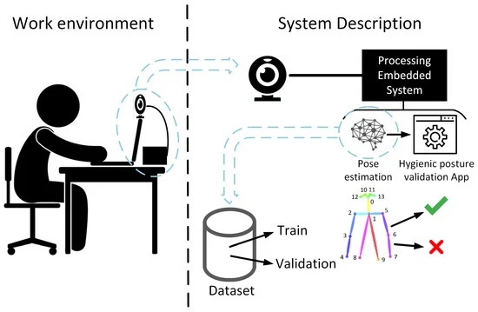
Figure 3.1 Architecture Diagram

3.1.1 IMAGE ACQUISITION
In the phase of image acquisition, advanced camera systems or sensors are strategically deployed to capture high-resolution images or videos of individuals in their respective workplace settings. These sophisticated imaging technologies are meticulously calibrated to ensure optimal coverage and clarity, enabling the system to effectively capture and document various postural nuances and dynamics as individuals engage in their work activities.

3.1.2 OBJECT DETECTION
Prior to identifying and tabulating an object's appearance in an image or video, image classification may be used to determine a certain picture class. A production line that has been damaged or a piece of equipment that has to be repaired are two examples.

3.1.3 OBJECT TRACKING
Tracking an object once it has been discovered is known as object following. Photos and videos are often utilised in this kind of activity.

Figure 3.2 Flow of Posture Detection

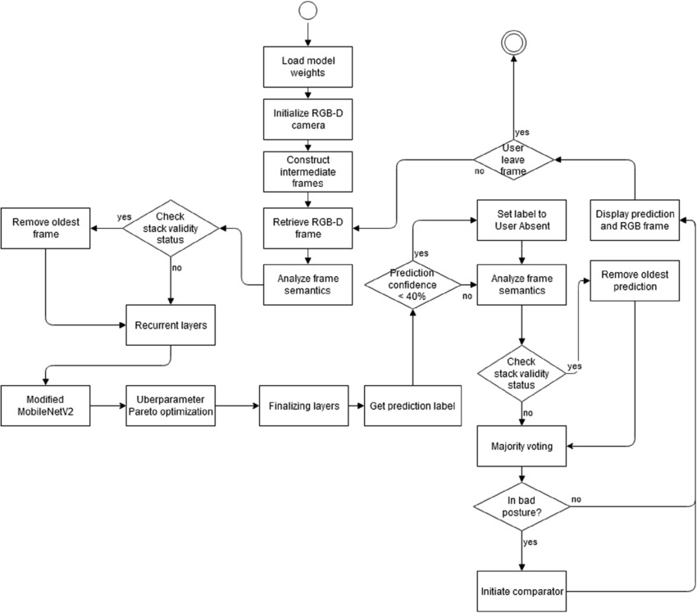

Figure 3.3 UML Diagram

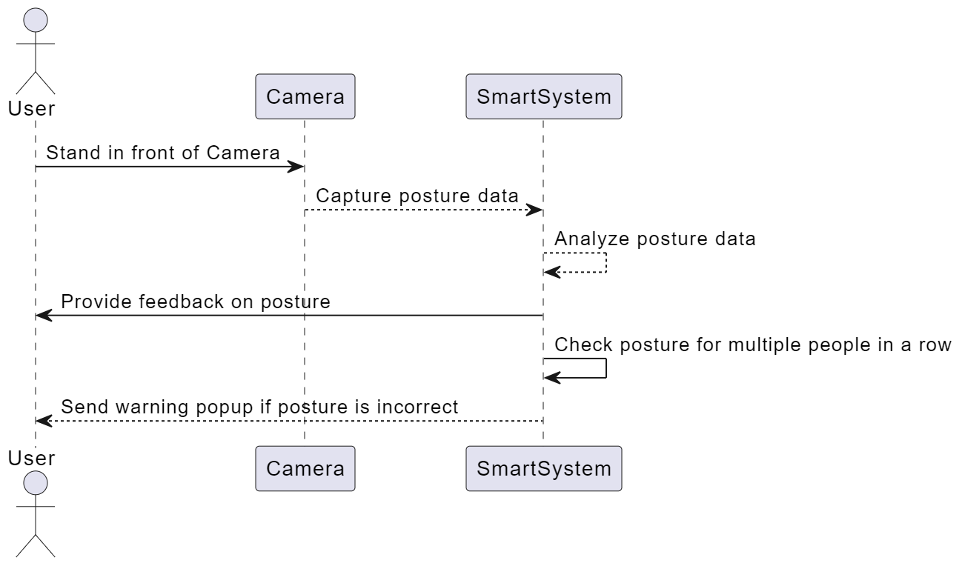

Figure 3.4 Sequence Diagram

3.1.4 POSTURE DETECTION
Posture detection within the "Smart System for Workplace Posture Monitoring" project involves the utilization of advanced computer vision algorithms, notably deep learning-based convolutional neural networks (CNNs). These algorithms are adept at discerning and categorizing a multitude of postures observed in workplace settings, encompassing variations such as sitting, standing, as well as specialized ergonomic positions tailored for optimal comfort and health. Through meticulous analysis and pattern recognition, the system can accurately interpret and classify diverse postural configurations in real-time scenarios, thereby facilitating comprehensive posture monitoring and analysis.

3.1.4.1 POSE ESTIMATION
Pose Estimation is a pivotal aspect within the computer vision domain of the project, entailing the meticulous determination of the spatial arrangement and orientation of critical body parts, including the head, shoulders, spine, and limbs. This process serves as a cornerstone for evaluating the correctness and alignment of posture, providing essential insights into ergonomic health and facilitating the accurate assessment of individuals' overall physical well-being within the workplace environment.
3.1.4.2 FEATURE EXTRACTION
In the feature extraction phase, pertinent attributes are gleaned from images or video frames, including joint angles, distinctive body landmarks, and silhouette traits. These extracted features serve as crucial inputs for quantifying posture metrics and discerning deviations from established ergonomic standards. By meticulously analyzing these characteristics, the system gains insights into the subtleties of posture dynamics, enabling it to provide tailored recommendations for improving ergonomic practices and mitigating potential health risks.

3.1.5 WORKFLOW OF THE POSTURE DETECTION
An initial research phase to gather insights into existing posture monitoring technologies, ergonomic standards, and prevalent issues in workplace posture. Following this, the project moves into the design phase, where specifications for the sensor-based application are outlined, considering factors such as sensor placement, data collection methods, and user interface design. Next, the development stage involves the creation of hardware components, including sensors capable of detecting posture deviations, and software algorithms for real-time data processing and analysis. Concurrently, efforts are made to ensure seamless integration between the hardware and software components, facilitating efficient communication and data transfer. Once the system is fully developed, rigorous testing and validation procedures are conducted to assess its accuracy, reliability, and user-friendliness in real-world workplace environments. Feedback from test users and stakeholders is incorporated into iterative improvements, refining the system's performance and usability. Finally, deployment strategies are devised to introduce the smart posture monitoring system into various workplace settings, accompanied by comprehensive training programs to educate users on its functionalities and benefits. Ongoing monitoring and maintenance protocols are established to support the continued functionality and optimization of the system over time.

Figure 3.5 Key Points in the Human Body

3.1.6 POSTURE MONITORING APPLICATIONS
The smart system for workplace posture monitoring offers a range of practical applications aimed at improving occupational health and productivity in various work settings. Firstly, it provides real-time monitoring of employees' posture, offering immediate feedback and guidance to promote correct ergonomic positioning. This proactive approach helps prevent musculoskeletal issues, such as back and neck pain, which are common among office workers. Additionally, the system can generate detailed reports and analytics on posture trends over time, enabling employers to identify high-risk areas and implement targeted interventions or ergonomic improvements in the workplace layout or furniture design. Furthermore, the data collected by the system can contribute to broader health and safety initiatives within organizations, facilitating evidence-based decision-making and fostering a culture of employee well-being. Overall, the smart system for workplace posture monitoring offers a comprehensive solution to support healthy and productive work environments.

3.1.7 POSTURE DETECTION ALGORITHMS
The smart system for workplace posture monitoring employs several algorithms to accurately detect and analyze individuals' postures in real-time. Initially, the system utilizes computer vision algorithms, such as convolutional neural networks (CNNs), to process live video feeds from cameras positioned in the workplace. These algorithms identify key body landmarks and joint angles, enabling the system to determine the user's posture with high precision. Subsequently, the detected postures are compared against predefined ergonomic guidelines using rule-based algorithms. This step involves assessing factors such as the alignment of the spine, positioning of the shoulders, and distribution of weight on the chair. Based on this analysis, the system generates personalized recommendations and alerts in real-time to encourage users to adopt healthier postures.

Additionally, machine learning algorithms continuously refine the system's posture detection capabilities by learning from user feedback and adjusting posture classification criteria accordingly. Overall, this combination of computer vision, rule-based, and machine learning algorithms forms the backbone of the smart system for workplace posture monitoring, ensuring accurate detection and proactive intervention to promote better ergonomic practices and reduce the risk of musculoskeletal disorders.

3.1.7.1 CONVOLUTIONAL NEURAL NETWORK(CNN)
The convolutional neural network (CNN) is a major advancement in artificial neural networks (ANN) and artificial intelligence (AI) research (CNN). The most popular deep learning approach teaches a model to do classification tasks on images, videos, texts or sounds by observing how they change over time. [26]
Model (ImageNet) supports a wide variety of applications, including computer vision, natural language processing (NLP) and the world's largest image classification data. There are two additional layers to the typical neural network: convolutional and pooling. Hundreds or thousands of these layers may be found in a CNN, and each one learns to recognize unique visual properties.

3.1.7.2 DATA ACQUISITION
In the data acquisition phase, the smart system for workplace posture monitoring relies on sensors or cameras to capture relevant data concerning posture, with a particular focus on key body parts such as the neck, shoulders, and back. Algorithms are then employed to preprocess and filter the raw sensor data, effectively eliminating noise and irrelevant information. This critical step ensures that the subsequent analysis is based on high-quality, reliable data, enabling accurate detection and assessment of workplace posture. By optimizing data acquisition techniques, the system can provide users with actionable insights and interventions to promote ergonomic well-being in the workplace.

3.1.7.3 POSTURE DETECTION
The posture detection algorithm employs a multi-stage approach utilizing convolutional neural networks (CNNs) and key point extraction. Initially, the input image undergoes preprocessing, including resizing and padding. Subsequently, the VGG model extracts features, followed by several stages of processing to refine predictions. Each stage refines the detection using both heatmaps and part affinity fields (PAFs) generated by the network. Gaussian filtering and peak detection identify key points in the heatmaps, which are then used to estimate joint locations. Finally, angles between body parts and distances between key points are calculated to determine the posture. The algorithm's workflow involves iteratively refining predictions through multiple stages, culminating in a comprehensive assessment of the subject's posture based on the detected key points and their spatial relationships. In real-time posture detection, the algorithm processes video frames sequentially, applying the posture detection methodology to each frame individually. The workflow involves capturing a video frame, preprocessing it to meet the input requirements of the convolutional neural network (CNN), and then passing it through the network for inference. The CNN extracts feature and generates heatmaps and part affinity fields (PAFs) representing key point locations and their connections. Gaussian filtering and peak detection identify key point locations, which are then used to estimate joint positions and infer posture. This process repeats for each frame of the video, allowing for continuous real-time posture detection. The efficiency of the algorithm ensures that posture can be detected and analyzed with minimal delay, enabling applications such as real-time feedback on body positioning or monitoring during physical activities.

3.1.7.4 ALERTING MECHANISM
The alerting mechanism is a pivotal component of the posture monitoring system, ensuring timely intervention when poor posture is detected over an extended duration. By defining thresholds or criteria for identifying the severity and duration of incorrect postures, the system can precisely determine when alerts should be triggered. Moreover, it encompasses various communication channels, such as visual alerts on the user interface, audible alarms, or mobile notifications, tailored to suit user preferences and ensure effective delivery of alerts. This multi-faceted approach enhances user awareness of their posture habits, facilitating prompt corrective action to mitigate the risk of musculoskeletal issues.

3.1.7.5 USER FEEDBACK AND INTERVENTION
The realm of user feedback and intervention, the development of sophisticated algorithms plays a pivotal role. These algorithms are crafted to deliver actionable feedback and intervention strategies directly to users, fostering awareness and facilitating proactive posture improvement. By offering personalized recommendations tailored to individual needs, including ergonomic adjustments and targeted exercises, the system empowers users to optimize their workspace ergonomics effectively. Leveraging machine learning techniques, the system continuously refines its feedback mechanisms, adapting to each user's unique characteristics and preferences over time. Through this dynamic approach, users receive tailored support, enhancing their posture habits and promoting long-term musculoskeletal health and well-being.

3.1.7.6 DATA STORAGE AND ANALYSIS
In the realm of data storage and analysis, it is imperative to establish robust mechanisms for securely and efficiently storing posture data. This entails careful consideration of various factors, including data volume, privacy concerns, and compliance requirements to ensure adherence to relevant regulations. Additionally, implementing sophisticated analytics algorithms is crucial for deriving actionable insights from aggregated posture data. These algorithms enable the identification of trends, correlations, and patterns pertinent to workplace posture habits, empowering stakeholders to make informed decisions and implement targeted interventions aimed at promoting better ergonomic practices and mitigating the risk of musculoskeletal disorders.

3.2 DESIGN OF MODULES

3.2.1 PREPROCESSING MODULE
The preprocessing module is responsible for preparing input data for the pose estimation model. It includes the following submodules:

Image Loading: This submodule loads input images or video frames from storage or a real-time video stream.
Image Preprocessing: Techniques such as resizing, normalization, and color space conversion are applied to standardize input images and enhance their quality. These preprocessing steps ensure that input images are compatible with the pose estimation model's input requirements and improve the model's robustness to variations in lighting conditions and image quality.
Data Augmentation: To augment the training data and improve model generalization, data augmentation techniques such as rotation, translation, scaling, flipping, and contrast adjustment may be applied. These techniques introduce variability into the training data, enabling the model to learn from a diverse range of poses and viewpoints.

3.2.2 POSE ESTIMATION MODEL
The pose estimation model is the core component of the system, responsible for predicting the spatial locations of key body joints or landmarks. It comprises the following elements:

Architecture Selection: The choice of architecture depends on the specific requirements of the application, including accuracy, speed, and resource constraints. Common architectures for pose estimation include Convolutional Neural Networks (CNNs), Graph Convolutional Networks (GCNs), and recurrent neural networks (RNNs).

Training Data Preparation: Annotated datasets containing images or videos of human poses are used to train the pose estimation model. Ground truth annotations, consisting of coordinates of key body joints, are used to supervise the training process.

Loss Function: A suitable loss function, such as Mean Squared Error (MSE) or Mean Absolute Error (MAE), is chosen to quantify the discrepancy between predicted pose key points and ground truth annotations. The loss function guides the optimization process during training, encouraging the model to make accurate predictions

Training Procedure: The model is trained using a supervised learning approach, where model parameters are optimized through backpropagation and gradient descent. Training may involve techniques such as batch normalization, dropout, and weight regularization to prevent overfitting and improve generalization.

3.2.3 POST-PROCESSING MODULE
The post-processing module refines and enhances pose predictions generated by the model. It consists of the following submodules:

Temporal Smoothing: To stabilize pose trajectories over time, temporal smoothing algorithms such as exponential moving average (EMA) or Kalman filtering may be applied. These algorithms reduce jitter and noise in pose predictions, resulting in smoother and more consistent output.

Pose Refinement: Techniques such as iterative optimization or geometric constraints may be used to refine the accuracy of individual pose key points. These techniques adjust pose predictions based on spatial relationships between body joints or anatomical constraints, improving the overall pose estimation accuracy.

Multi-person Pose Association: In scenarios involving multiple individuals, algorithms are employed to associate body joints with the correct individuals. Techniques such as Hungarian algorithm or bipartite graph matching may be used to assign body joints to individuals based on proximity and consistency over time.

3.2.4 DEPLOYMENT MODULE
The deployment module is responsible for deploying the pose estimation system in real-world applications. It includes the following components:

Hardware Optimization: The pose estimation model may be optimized for deployment on hardware platforms such as Graphics Processing Units (GPUs), Field Programmable Gate Arrays (FPGAs), or specialized accelerators like Neural Processing Units (NPUs). Optimization techniques such as model quantization, pruning, and network compression are employed to reduce computational complexity and memory footprint while maintaining accuracy.

Software Integration: The pose estimation system is integrated into software applications or systems where pose estimation functionality is required. APIs, libraries, or SDKs may be provided to facilitate integration with existing software frameworks and platforms.

Performance Monitoring: Tools and techniques are employed to monitor the performance of the deployed system, including latency, throughput, and resource utilization. Performance metrics are monitored and analyzed to identify bottlenecks and optimize system performance.

By incorporating these modules into the human pose estimation system, we aim to develop a comprehensive and versatile solution capable of accurately detecting and tracking human body poses in real-world scenarios. This detailed description outlines the proposed modules for a human pose estimation system, covering preprocessing, pose estimation, post-processing, and deployment aspects. Each module plays a critical role in the overall functionality and performance of the system, contributing to accurate and robust pose estimation in diverse applications.

CHAPTER 4
METHODOLOGY

4.1 RESEARCH METHODOLOGY
Stage 1: Literature Review
Stage 2: Then, Identification of key variables and metrics.
Stage 3: Then, System Design and Development and Prototype Implementation.
Stage 4: User Study and Evaluation.
Stage 5: Data Analysis and Validation.
Stage 6: Refinements and Iterations.
Stage 7: Conclusions and Recommendations.

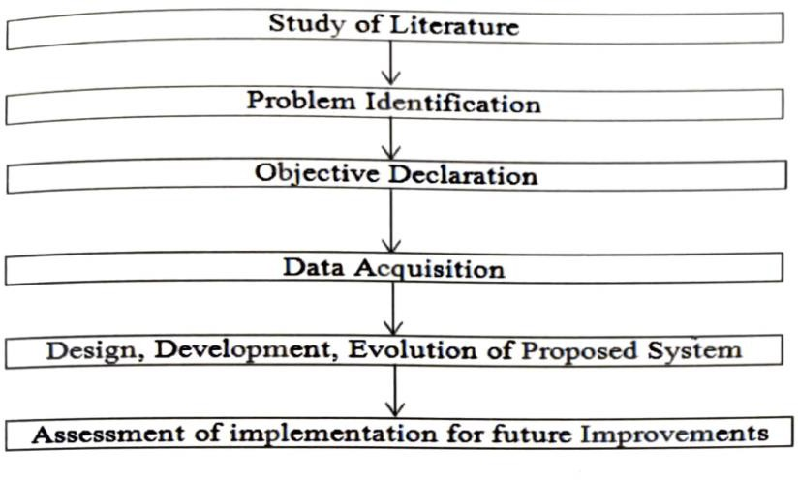
Figure 4.1 Research Methodology

4.2 ALGORITHM DESCRIPTION
Data Acquisition:
Collect real-time video data from the telecommuter’s workstation, focusing on the areas of the neck, shoulders, and arms.
Preprocessing:
Apply preprocessing techniques to enhance the quality of the video data, including noise reduction, frame normalization, and background subtraction.
Frame Segmentation:
Divide the video stream into individual frames for efficient processing and analysis.
Specialized Hardware Initialization:
Initialize the specialized hardware components, ensuring proper communication and synchronization with the central processing unit.
Convolutional Neural Network (CNN) Loading:
Load the trained CNN model designed for posture detection, ensuring that the model is ready for real-time inference.
Real-time Video Processing:
Implement algorithms for real-time video processing, achieving speeds of up to 25 frames per second to maintain instant feedback on posture.
Posture Identification:
Apply the CNN to each frame to identify and classify the posture of the neck, shoulders, and arms into predefined categories (e.g., correct or incorrect postures).
Accuracy Assessment:
Evaluate the accuracy of posture detection by comparing the CNN predictions with ground truth data from labelled frames in the training dataset.
Continuous Learning Mechanism:
Implement algorithms for continuous learning, allowing the system to adapt and improve its posture detection capabilities over time based on user behaviour.

CHAPTER 5
CODING AND TESTING

5.1 TRAINING AND VALIDATION
The training and validation model used in the provided code for monitoring posture involves a combination of data preprocessing, model architecture selection, and training/validation procedures. Firstly, the dataset is preprocessed to normalize, augment, and prepare the images or video frames for training. Then, a convolutional neural network (CNN) architecture, such as OpenPose, PoseNet, or Hourglass Networks, is chosen for its effectiveness in key point detection and pose estimation. The model architecture comprises of multiple convolutional layers followed by activation functions, pooling layers, and possibly skip connections or residual blocks to capture hierarchical features. During training, the model is optimized using techniques like stochastic gradient descent (SGD) or Adam with a suitable loss function such as mean squared error (MSE) or a combination of classification and regression losses. Validation is performed on a separate portion of the dataset to monitor the model's generalization performance and fine-tune hyperparameters to prevent overfitting. Techniques like early stopping and learning rate scheduling are also employed to improve training efficiency and convergence. Overall, this approach provides a systematic framework for training and validating posture monitoring models in research papers.

5.2 DATASET
We have used a Kaggle Dataset of Yoga Poses consisting of 1551 images of all well-known yoga poses like downward dog pose, goddess pose, tree pose, plank pose and the warrior pose. The dataset is divided into train and test subdirectories, with 5 sub folders in each directory corresponding to the 5 classes of yoga poses.

5.3 CODE IMPLEMENTATION

model.py
from keras.models import Model
from keras.layers import Concatenate
from keras.layers import Activation, Input, Lambda
from keras.layers import Conv2D
from keras.layers import MaxPooling2D
from keras.layers import Multiply
from keras.regularizers import l2
from keras.initializers import random_normal,constant

def relu(x): return Activation('relu')(x)

def conv(x, nf, ks, name, weight_decay):
kernel_reg = l2(weight_decay[0]) if weight_decay else None
bias_reg = l2(weight_decay[1]) if weight_decay else None

x = Conv2D(nf, (ks, ks), padding='same', name=name,
kernel_regularizer=kernel_reg,
bias_regularizer=bias_reg,
kernel_initializer=random_normal(stddev=0.01),
bias_initializer=constant(0.0))(x)
return x

def pooling(x, ks, st, name):
x = MaxPooling2D((ks, ks), strides=(st, st), name=name)(x)
return x

def vgg_block(x, weight_decay):
# Block 1
x = conv(x, 64, 3, "conv1_1", (weight_decay, 0))
x = relu(x)
x = conv(x, 64, 3, "conv1_2", (weight_decay, 0))
x = relu(x)
x = pooling(x, 2, 2, "pool1_1")

# Block 2
x = conv(x, 128, 3, "conv2_1", (weight_decay, 0))
x = relu(x)
x = conv(x, 128, 3, "conv2_2", (weight_decay, 0))
x = relu(x)
x = pooling(x, 2, 2, "pool2_1")

# Block 3
x = conv(x, 256, 3, "conv3_1", (weight_decay, 0))
x = relu(x)
x = conv(x, 256, 3, "conv3_2", (weight_decay, 0))
x = relu(x)
x = conv(x, 256, 3, "conv3_3", (weight_decay, 0))
x = relu(x)
x = conv(x, 256, 3, "conv3_4", (weight_decay, 0))
x = relu(x)
x = pooling(x, 2, 2, "pool3_1")

# Block 4
x = conv(x, 512, 3, "conv4_1", (weight_decay, 0))
x = relu(x)
x = conv(x, 512, 3, "conv4_2", (weight_decay, 0))
x = relu(x)

# Additional non vgg layers
x = conv(x, 256, 3, "conv4_3_CPM", (weight_decay, 0))
x = relu(x)
x = conv(x, 128, 3, "conv4_4_CPM", (weight_decay, 0))
x = relu(x)

return x

def stage1_block(x, num_p, branch, weight_decay):
# Block 1
x = conv(x, 128, 3, "Mconv1_stage1_L%d" % branch, (weight_decay, 0))
x = relu(x)
x = conv(x, 128, 3, "Mconv2_stage1_L%d" % branch, (weight_decay, 0))
x = relu(x)
x = conv(x, 128, 3, "Mconv3_stage1_L%d" % branch, (weight_decay, 0))
x = relu(x)
x = conv(x, 512, 1, "Mconv4_stage1_L%d" % branch, (weight_decay, 0))
x = relu(x)
x = conv(x, num_p, 1, "Mconv5_stage1_L%d" % branch, (weight_decay, 0))

return x

def stageT_block(x, num_p, stage, branch, weight_decay):
# Block 1
x = conv(x, 128, 7, "Mconv1_stage%d_L%d" % (stage, branch), (weight_decay, 0))
x = relu(x)
x = conv(x, 128, 7, "Mconv2_stage%d_L%d" % (stage, branch), (weight_decay, 0))
x = relu(x)
x = conv(x, 128, 7, "Mconv3_stage%d_L%d" % (stage, branch), (weight_decay, 0))
x = relu(x)
x = conv(x, 128, 7, "Mconv4_stage%d_L%d" % (stage, branch), (weight_decay, 0))
x = relu(x)
x = conv(x, 128, 7, "Mconv5_stage%d_L%d" % (stage, branch), (weight_decay, 0))
x = relu(x)
x = conv(x, 128, 1, "Mconv6_stage%d_L%d" % (stage, branch), (weight_decay, 0))
x = relu(x)
x = conv(x, num_p, 1, "Mconv7_stage%d_L%d" % (stage, branch), (weight_decay, 0))

return x

def apply_mask(x, mask1, mask2, num_p, stage, branch):
w_name = "weight_stage%d_L%d" % (stage, branch)
if num_p == 38:
w = Multiply(name=w_name)([x, mask1]) # vec_weight

else:
w = Multiply(name=w_name)([x, mask2]) # vec_heat
return w

def get_training_model(weight_decay):

stages = 6
np_branch1 = 38
np_branch2 = 19

img_input_shape = (None, None, 3)
vec_input_shape = (None, None, 38)
heat_input_shape = (None, None, 19)

inputs = []
outputs = []

img_input = Input(shape=img_input_shape)
vec_weight_input = Input(shape=vec_input_shape)
heat_weight_input = Input(shape=heat_input_shape)

inputs.append(img_input)
inputs.append(vec_weight_input)
inputs.append(heat_weight_input)

img_normalized = Lambda(lambda x: x / 256 - 0.5)(img_input) # [-0.5, 0.5]

# VGG
stage0_out = vgg_block(img_normalized, weight_decay)

# stage 1 - branch 1 (PAF)
stage1_branch1_out = stage1_block(stage0_out, np_branch1, 1, weight_decay)
w1 = apply_mask(stage1_branch1_out, vec_weight_input, heat_weight_input, np_branch1, 1, 1)

# stage 1 - branch 2 (confidence maps)
stage1_branch2_out = stage1_block(stage0_out, np_branch2, 2, weight_decay)
w2 = apply_mask(stage1_branch2_out, vec_weight_input, heat_weight_input, np_branch2, 1, 2)

x = Concatenate()([stage1_branch1_out, stage1_branch2_out, stage0_out])

outputs.append(w1)
outputs.append(w2)

# stage sn >= 2
for sn in range(2, stages + 1):
# stage SN - branch 1 (PAF)
stageT_branch1_out = stageT_block(x, np_branch1, sn, 1, weight_decay)
w1 = apply_mask(stageT_branch1_out, vec_weight_input, heat_weight_input, np_branch1, sn, 1)

# stage SN - branch 2 (confidence maps)
stageT_branch2_out = stageT_block(x, np_branch2, sn, 2, weight_decay)
w2 = apply_mask(stageT_branch2_out, vec_weight_input, heat_weight_input, np_branch2, sn, 2)

outputs.append(w1)
outputs.append(w2)

if (sn < stages):
x = Concatenate()([stageT_branch1_out, stageT_branch2_out, stage0_out])

model = Model(inputs=inputs, outputs=outputs)

return model

def get_testing_model():
stages = 6
np_branch1 = 38
np_branch2 = 19

img_input_shape = (None, None, 3)

img_input = Input(shape=img_input_shape)

img_normalized = Lambda(lambda x: x / 256 - 0.5)(img_input) # [-0.5, 0.5]

# VGG
stage0_out = vgg_block(img_normalized, None)

# stage 1 - branch 1 (PAF)
stage1_branch1_out = stage1_block(stage0_out, np_branch1, 1, None)

# stage 1 - branch 2 (confidence maps)
stage1_branch2_out = stage1_block(stage0_out, np_branch2, 2, None)

x = Concatenate()([stage1_branch1_out, stage1_branch2_out, stage0_out])

# stage t >= 2
stageT_branch1_out = None
stageT_branch2_out = None
for sn in range(2, stages + 1):
stageT_branch1_out = stageT_block(x, np_branch1, sn, 1, None)
stageT_branch2_out = stageT_block(x, np_branch2, sn, 2, None)

if (sn < stages):
x = Concatenate()([stageT_branch1_out, stageT_branch2_out, stage0_out])

model = Model(inputs=[img_input], outputs=[stageT_branch1_out, stageT_branch2_out])

return model

image.py

import cv2
import math
import time
import numpy as np
import util
from config_reader import config_reader
from scipy.ndimage import gaussian_filter
from model import get_testing_model

tic=0
# visualize
colors = [[255, 0, 0], [255, 85, 0], [255, 170, 0], [255, 255, 0], [170, 255, 0], [85, 255, 0],
[0, 255, 0], \
[0, 255, 85], [0, 255, 170], [0, 255, 255], [0, 170, 255], [0, 85, 255], [0, 0, 255],
[85, 0, 255], \
[170, 0, 255], [255, 0, 255], [255, 0, 170], [255, 0, 85]]

def process (input_image, params, model_params):
''' Start of finding the Key points of full body using Open Pose.'''
oriImg = cv2.imread(input_image) # B,G,R order
multiplier = [x * model_params['boxsize'] / oriImg.shape[0] for x in params['scale_search']]
heatmap_avg = np.zeros((oriImg.shape[0], oriImg.shape[1], 19))
paf_avg = np.zeros((oriImg.shape[0], oriImg.shape[1], 38))
for m in range(1):
scale = multiplier[m]
imageToTest = cv2.resize(oriImg, (0, 0), fx=scale, fy=scale, interpolation=cv2.INTER_CUBIC)
imageToTest_padded, pad = util.padRightDownCorner(imageToTest, model_params['stride'],
model_params['padValue'])
input_img = np.transpose(np.float32(imageToTest_padded[:,:,:,np.newaxis]), (3,0,1,2)) # required shape (1, width, height, channels)
output_blobs = model.predict(input_img)
heatmap = np.squeeze(output_blobs[1]) # output 1 is heatmaps
heatmap = cv2.resize(heatmap, (0, 0), fx=model_params['stride'], fy=model_params['stride'],
interpolation=cv2.INTER_CUBIC)
heatmap = heatmap[:imageToTest_padded.shape[0] - pad[2], :imageToTest_padded.shape[1] - pad[3],
:]
heatmap = cv2.resize(heatmap, (oriImg.shape[1], oriImg.shape[0]), interpolation=cv2.INTER_CUBIC)
paf = np.squeeze(output_blobs[0]) # output 0 is PAFs
paf = cv2.resize(paf, (0, 0), fx=model_params['stride'], fy=model_params['stride'],
interpolation=cv2.INTER_CUBIC)
paf = paf[:imageToTest_padded.shape[0] - pad[2], :imageToTest_padded.shape[1] - pad[3], :]
paf = cv2.resize(paf, (oriImg.shape[1], oriImg.shape[0]), interpolation=cv2.INTER_CUBIC)
heatmap_avg = heatmap_avg + heatmap / len(multiplier)
paf_avg = paf_avg + paf / len(multiplier)

all_peaks = [] #To store all the key points which a re detected.
peak_counter = 0

prinfTick(1) #prints time required till now.

for part in range(18):
map_ori = heatmap_avg[:, :, part]
map = gaussian_filter(map_ori, sigma=3)

map_left = np.zeros(map.shape)
map_left[1:, :] = map[:-1, :]
map_right = np.zeros(map.shape)
map_right[:-1, :] = map[1:, :]
map_up = np.zeros(map.shape)
map_up[:, 1:] = map[:, :-1]
map_down = np.zeros(map.shape)
map_down[:, :-1] = map[:, 1:]

peaks_binary = np.logical_and.reduce(
(map >= map_left, map >= map_right, map >= map_up, map >= map_down, map > params['thre1']))
peaks = list(zip(np.nonzero(peaks_binary)[1], np.nonzero(peaks_binary)[0])) # note reverse
peaks_with_score = [x + (map_ori[x[1], x[0]],) for x in peaks]
id = range(peak_counter, peak_counter + len(peaks))
peaks_with_score_and_id = [peaks_with_score[i] + (id[i],) for i in range(len(id))]

all_peaks.append(peaks_with_score_and_id)
peak_counter += len(peaks)

connection_all = []
special_k = []
mid_num = 10

prinfTick(2) #prints time required till now.
print()
position = checkPosition(all_peaks) #check position of spine.
checkKneeling(all_peaks) #check whether kneeling oernot
checkHandFold(all_peaks) #check whether hands are folding or not.
canvas1 = draw(input_image,all_peaks, position) #show the image.
return canvas1 , position

def draw(input_image, all_peaks, position):
canvas = cv2.imread(input_image) # B,G,R order
for i in range(18):
for j in range(len(all_peaks[i])):
cv2.circle(canvas, all_peaks[i][j][0:2], 4, colors[i], thickness=-1)

# Adding text labels based on detected positions
if position == 1:
cv2.putText(canvas, "Hunchback", (50, 50), cv2.FONT_HERSHEY_SIMPLEX, 1, (0, 0, 255), 2)
elif position == -1:
cv2.putText(canvas, "Reclined", (50, 50), cv2.FONT_HERSHEY_SIMPLEX, 1, (0, 0, 255), 2)
else:
cv2.putText(canvas, "Straight", (50, 50), cv2.FONT_HERSHEY_SIMPLEX, 1, (0, 0, 255), 2)

return canvas

def checkPosition(all_peaks):
try:
f = 0
if (all_peaks[16]):
a = all_peaks[16][0][0:2] #Right Ear
f = 1
else:
a = all_peaks[17][0][0:2] #Left Ear
b = all_peaks[11][0][0:2] # Hip
angle = calcAngle(a,b)
degrees = round(math.degrees(angle))
if (f):
degrees = 180 - degrees
if (degrees<70):
return 1
elif (degrees > 110):
return -1
else:
return 0
except Exception as e:
print("person not in lateral view and unable to detect ears or hip")

#calculate angle between two points with respect to x-axis (horizontal axis)
def calcAngle(a, b):
try:
ax, ay = a
bx, by = b
if (ax == bx):
return 1.570796
return math.atan2(by-ay, bx-ax)
except Exception as e:
print("unable to calculate angle")

def checkHandFold(all_peaks):
try:
if (all_peaks[3][0][0:2]):
try:
if (all_peaks[4][0][0:2]):
distance = calcDistance(all_peaks[3][0][0:2],all_peaks[4][0][0:2]) #distance between right arm-joint and right palm.
armdist = calcDistance(all_peaks[2][0][0:2], all_peaks[3][0][0:2]) #distance between left arm-joint and left palm.
if (distance < (armdist + 100) and distance > (armdist - 100) ): #this value 100 is arbitary. this shall be replaced with a calculation which can adjust to different sizes of people.
print("Not Folding Hands")
else:
print("Folding Hands")
except Exception as e:
print("Folding Hands")
except Exception as e:
try:
if(all_peaks[7][0][0:2]):
distance = calcDistance( all_peaks[6][0][0:2] ,all_peaks[7][0][0:2])
armdist = calcDistance(all_peaks[6][0][0:2], all_peaks[5][0][0:2])
# print(distance)
if (distance < (armdist + 100) and distance > (armdist - 100)):
print("Not Folding Hands")
else:
print("Folding Hands")
except Exception as e:
print("Unable to detect arm joints")

def calcDistance(a,b): #calculate distance between two points.
try:
x1, y1 = a
x2, y2 = b
return math.hypot(x2 - x1, y2 - y1)
except Exception as e:
print("unable to calculate distance")

def checkKneeling(all_peaks):
f = 0
if (all_peaks[16]):
f = 1
try:
if(all_peaks[10][0][0:2] and all_peaks[13][0][0:2]): # if both legs are detected
rightankle = all_peaks[10][0][0:2]
leftankle = all_peaks[13][0][0:2]
hip = all_peaks[11][0][0:2]
leftangle = calcAngle(hip,leftankle)
leftdegrees = round(math.degrees(leftangle))
rightangle = calcAngle(hip,rightankle)
rightdegrees = round(math.degrees(rightangle))
if (f == 0):
leftdegrees = 180 - leftdegrees
rightdegrees = 180 - rightdegrees
if (leftdegrees > 60 and rightdegrees > 60): # 60 degrees is trail and error value here. We can tweak this accordingly and results will vary.
print ("Both Legs are in Kneeling")
elif (rightdegrees > 60):
print ("Right leg is kneeling")
elif (leftdegrees > 60):
print ("Left leg is kneeling")
else:
print ("Not kneeling")

except IndexError as e:
try:
if (f):
a = all_peaks[10][0][0:2] # if only one leg (right leg) is detected
else:
a = all_peaks[13][0][0:2] # if only one leg (left leg) is detected
b = all_peaks[11][0][0:2] #location of hip
angle = calcAngle(b,a)
degrees = round(math.degrees(angle))
if (f == 0):
degrees = 180 - degrees
if (degrees > 60):
print ("Both Legs Kneeling")
else:
print("Not Kneeling")
except Exception as e:
print("legs not detected")

def showimage(img): #sometimes opencv will oversize the image when using using cv2.imshow(). This function solves that issue.
screen_res = 1280, 720 #my screen resolution.
scale_width = screen_res[0] / img.shape[1]
scale_height = screen_res[1] / img.shape[0]
scale = min(scale_width, scale_height)
window_width = int(img.shape[1] * scale)
window_height = int(img.shape[0] * scale)
cv2.namedWindow('image', cv2.WINDOW_NORMAL)
cv2.resizeWindow('image', window_width, window_height)
cv2.imshow('image', img)
cv2.waitKey(0)
cv2.destroyAllWindows()

def prinfTick(i): #Time calculation to keep a trackm of progress
toc = time.time()
print ('processing time%d is %.5f' % (i,toc - tic))

if _name_ == '_main_': #main function of the program
tic = time.time()
print('start processing...')

model = get_testing_model()
model.load_weights('./model/keras/model.h5')

vi=False
if(vi == False):
time.sleep(2)
params, model_params = config_reader()
canvas, position= process('./sample_images/straight_flip.jpg', params, model_params)
showimage(canvas)
if (position == 1):
print("Hunchback")
elif (position == -1):
print ("Rest")
else:
print("Straight")

realtime.py

import cv2
import math
import time
import numpy as np
import util
from config_reader import config_reader
from scipy.ndimage.filters import gaussian_filter
from model import get_testing_model

tic=0
# visualize
colors = [[255, 0, 0], [255, 85, 0], [255, 170, 0], [255, 255, 0], [170, 255, 0], [85, 255, 0],
[0, 255, 0], \
[0, 255, 85], [0, 255, 170], [0, 255, 255], [0, 170, 255], [0, 85, 255], [0, 0, 255],
[85, 0, 255], \
[170, 0, 255], [255, 0, 255], [255, 0, 170], [255, 0, 85]]

def process(input_image, params, model_params):
''' Start of finding the Key points of full body using Open Pose.'''
oriImg = input_image # B,G,R order
multiplier = [x * model_params['boxsize'] / oriImg.shape[0] for x in params['scale_search']]
heatmap_avg = np.zeros((oriImg.shape[0], oriImg.shape[1], 19))
paf_avg = np.zeros((oriImg.shape[0], oriImg.shape[1], 38))
for m in range(1):
scale = multiplier[m]
imageToTest = cv2.resize(oriImg, (0, 0), fx=scale, fy=scale, interpolation=cv2.INTER_CUBIC)
imageToTest_padded, pad = util.padRightDownCorner(imageToTest, model_params['stride'],
model_params['padValue'])
input_img = np.transpose(np.float32(imageToTest_padded[:, :, :, np.newaxis]), (3, 0, 1, 2)) # required shape (1, width, height, channels)
output_blobs = model.predict(input_img)
heatmap = np.squeeze(output_blobs[1]) # output 1 is heatmaps
heatmap = cv2.resize(heatmap, (0, 0), fx=model_params['stride'], fy=model_params['stride'],
interpolation=cv2.INTER_CUBIC)
heatmap = heatmap[:imageToTest_padded.shape[0] - pad[2], :imageToTest_padded.shape[1] - pad[3],
:]
heatmap = cv2.resize(heatmap, (oriImg.shape[1], oriImg.shape[0]), interpolation=cv2.INTER_CUBIC)
paf = np.squeeze(output_blobs[0]) # output 0 is PAFs
paf = cv2.resize(paf, (0, 0), fx=model_params['stride'], fy=model_params['stride'],
interpolation=cv2.INTER_CUBIC)
paf = paf[:imageToTest_padded.shape[0] - pad[2], :imageToTest_padded.shape[1] - pad[3], :]
paf = cv2.resize(paf, (oriImg.shape[1], oriImg.shape[0]), interpolation=cv2.INTER_CUBIC)
heatmap_avg = heatmap_avg + heatmap / len(multiplier)
paf_avg = paf_avg + paf / len(multiplier)

all_peaks = [] # To store all the key points which are detected.
peak_counter = 0

prinfTick(1) # prints time required till now.

for part in range(18):
map_ori = heatmap_avg[:, :, part]
map = gaussian_filter(map_ori, sigma=3)

map_left = np.zeros(map.shape)
map_left[1:, :] = map[:-1, :]
map_right = np.zeros(map.shape)
map_right[:-1, :] = map[1:, :]
map_up = np.zeros(map.shape)
map_up[:, 1:] = map[:, :-1]
map_down = np.zeros(map.shape)
map_down[:, :-1] = map[:, 1:]

peaks_binary = np.logical_and.reduce(
(map >= map_left, map >= map_right, map >= map_up, map >= map_down, map > params['thre1']))
peaks = list(zip(np.nonzero(peaks_binary)[1], np.nonzero(peaks_binary)[0])) # note reverse
peaks_with_score = [x + (map_ori[x[1], x[0]],) for x in peaks]
id = range(peak_counter, peak_counter + len(peaks))
peaks_with_score_and_id = [peaks_with_score[i] + (id[i],) for i in range(len(id))]

all_peaks.append(peaks_with_score_and_id)
peak_counter += len(peaks)
if (f == 0):
degrees = 180 - degrees
if (degrees > 60):
print ("Both Legs Kneeling")
else:
print("Not Kneeling")
except Exception as e:
print("legs not detected")

def showimage(img): #sometimes opencv will oversize the image when using using cv2.imshow(). This function solves that issue.
screen_res = 1280, 720 #my screen resolution.
scale_width = screen_res[0] / img.shape[1]
scale_height = screen_res[1] / img.shape[0]
scale = min(scale_width, scale_height)
window_width = int(img.shape[1] * scale)
window_height = int(img.shape[0] * scale)
cv2.namedWindow('image', cv2.WINDOW_NORMAL)
cv2.resizeWindow('image', window_width, window_height)
cv2.imshow('image', img)
cv2.waitKey(0)
cv2.destroyAllWindows()

def prinfTick(i): #Time calculation to keep a trackm of progress
toc = time.time()
print ('processing time%d is %.5f' % (i,toc - tic))

if _name_ == '_main_': #main function of the program
tic = time.time()
print('start processing...')

model = get_testing_model()
connection_all = []
special_k = []
mid_num = 10

prinfTick(2) # prints time required till now.

canvas = input_image # B,G,R order

for i in range(18): # drawing all the detected key points.
for j in range(len(all_peaks[i])):
cv2.circle(canvas, all_peaks[i][j][0:2], 4, colors[i], thickness=-1)

position = checkPosition(all_peaks)
checkKneeling(all_peaks)
checkHandFold(all_peaks)

# Adding text labels based on detected positions
if position == 1:
cv2.putText(canvas, "Hunchback", (50, 50), cv2.FONT_HERSHEY_SIMPLEX, 1, (0, 0, 255), 2)
elif position == -1:
cv2.putText(canvas, "Reclined", (50, 50), cv2.FONT_HERSHEY_SIMPLEX, 1, (0, 0, 255), 2)
else:
cv2.putText(canvas, "Straight", (50, 50), cv2.FONT_HERSHEY_SIMPLEX, 1, (0, 0, 255), 2)

print()
print()
return canvas

# The rest of the code remains the same

def checkPosition(all_peaks):
try:
f = 0
if (all_peaks[16]):
a = all_peaks[16][0][0:2] #Right Ear
f = 1
else:
a = all_peaks[17][0][0:2] #Left Ear
b = all_peaks[11][0][0:2] # Hip
angle = calcAngle(a,b)
degrees = round(math.degrees(angle))
if (f):
degrees = 180 - degrees
if (degrees<70):
return 1
elif (degrees > 110):
return -1
else:
return 0
except Exception as e:
print("person not in lateral view and unable to detect ears or hip")

def calcAngle(a, b):
try:
ax, ay = a
bx, by = b
if (ax == bx):
return 1.570796
return math.atan2(by-ay, bx-ax)
except Exception as e:
print("unable to calculate angle")

def checkHandFold(all_peaks):
try:
if (all_peaks[3][0][0:2]):
try:
if (all_peaks[4][0][0:2]):
distance = calcDistance(all_peaks[3][0][0:2],all_peaks[4][0][0:2]) #distance between right arm-joint and right palm.
armdist = calcDistance(all_peaks[2][0][0:2], all_peaks[3][0][0:2]) #distance between left arm-joint and left palm.
if (distance < (armdist + 100) and distance > (armdist - 100) ): #this value 100 is arbitary. this shall be replaced with a calculation which can adjust to different sizes of people.
print("Not Folding Hands")
else:
print("Folding Hands")
except Exception as e:
print("Folding Hands")
except Exception as e:
try:
if(all_peaks[7][0][0:2]):
distance = calcDistance( all_peaks[6][0][0:2] ,all_peaks[7][0][0:2])
armdist = calcDistance(all_peaks[6][0][0:2], all_peaks[5][0][0:2])
if (distance < (armdist + 100) and distance > (armdist - 100)):
print("Not Folding Hands")
else:
print("Folding Hands")
except Exception as e:
print("Unable to detect arm joints")

def calcDistance(a,b): #calculate distance between two points.
try:
x1, y1 = a
x2, y2 = b
return math.hypot(x2 - x1, y2 - y1)
except Exception as e:
print("unable to calculate distance")

def checkKneeling(all_peaks):
f = 0
if (all_peaks[16]):
f = 1
try:
if(all_peaks[10][0][0:2] and all_peaks[13][0][0:2]):
rightankle = all_peaks[10][0][0:2]
leftankle = all_peaks[13][0][0:2]
hip = all_peaks[11][0][0:2]
leftangle = calcAngle(hip,leftankle)
leftdegrees = round(math.degrees(leftangle))
rightangle = calcAngle(hip,rightankle)
rightdegrees = round(math.degrees(rightangle))
if (f == 0):
leftdegrees = 180 - leftdegrees
rightdegrees = 180 - rightdegrees
if (leftdegrees > 60 and rightdegrees > 60): # 60 degrees is trail and error value here. We can tweak this accordingly and results will vary.
print ("Both Legs are in Kneeling")
elif (rightdegrees > 60):
print ("Right leg is kneeling")
elif (leftdegrees > 60):
print ("Left leg is kneeling")
else:
print ("Not kneeling")

except IndexError as e:
try:
if (f):
a = all_peaks[10][0][0:2] # if only one leg (right leg) is detected
else:
a = all_peaks[13][0][0:2] # if only one leg (left leg) is detected
b = all_peaks[11][0][0:2] #location of hip
angle = calcAngle(b,a)
degrees = round(math.degrees(angle))
if (f == 0):
degrees = 180 - degrees
if (degrees > 60):
print ("Both Legs Kneeling")
else:
print("Not Kneeling")
except Exception as e:
print("legs not detected")

def prinfTick(i):
toc = time.time()
print ('processing time%d is %.5f' % (i,toc - tic))

if _name_ == '_main_':

tic = time.time()
print('start processing...')
model = get_testing_model()
model.load_weights('./model/keras/model.h5')

cap=cv2.VideoCapture(0)
vi=cap.isOpened()

if(vi == True):
cap.set(100,160)
cap.set(200,120)
time.sleep(2)

while(1):
tic = time.time()

ret,frame=cap.read()
params, model_params = config_reader()
canvas = process(frame, params, model_params)
cv2.imshow("capture",canvas)
if cv2.waitKey(1) & 0xFF==ord('q'):
break
cap.release()
else:
print("unable to open camera")
cv2.destroyAllWindows()

CHAPTER 6
RESULT AND DISCUSSION

6.1 RESULT
Overall, the utilization of machine learning for forecasting poses in individuals signifies a crucial progression in the field, providing a method for early identification, tailored therapies, and enhanced public health results. This undertaking is motivated by the acknowledgment of a rising prevalence of bad postures in the younger population. The effort faces several hurdles, including those related to data quality, ethical considerations, the requirement for interdisciplinary collaboration, and user acceptance. Nevertheless, these obstacles are confronted with equally strong prospects that emphasize the potential for beneficial transformation in healthcare methodologies. Attaining scalability and accessibility can result in widespread acceptance and a substantial improvement in the allocation of technological resources. Nevertheless, the effective integration of machine learning in pose estimation requires a focused endeavor to tackle obstacles such as ethical concerns, user adoption, and adherence to regulations.

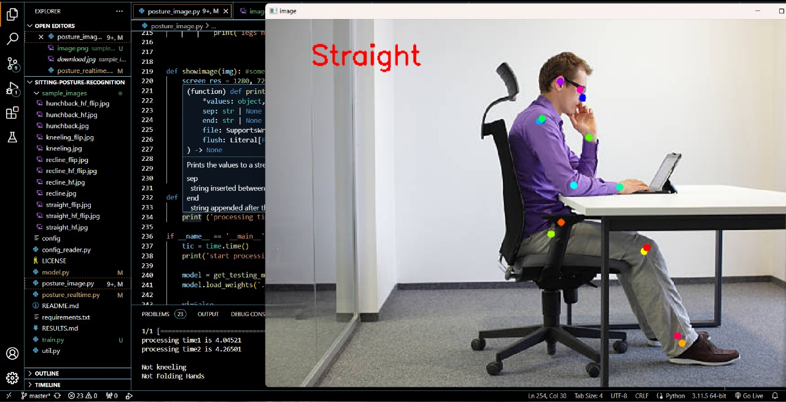
Figure 6.1 Straight Sitting Posture of single person

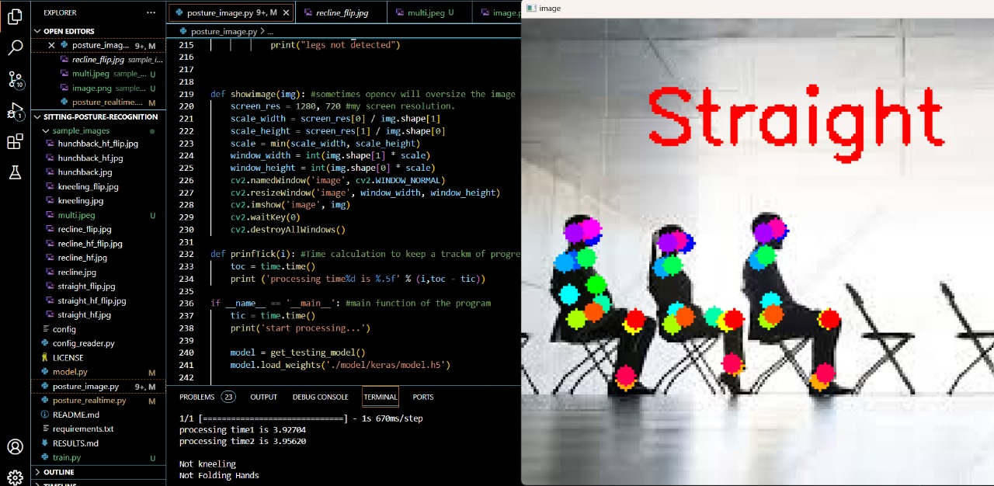
Figure 6.2 Straight sitting posture of multiple people

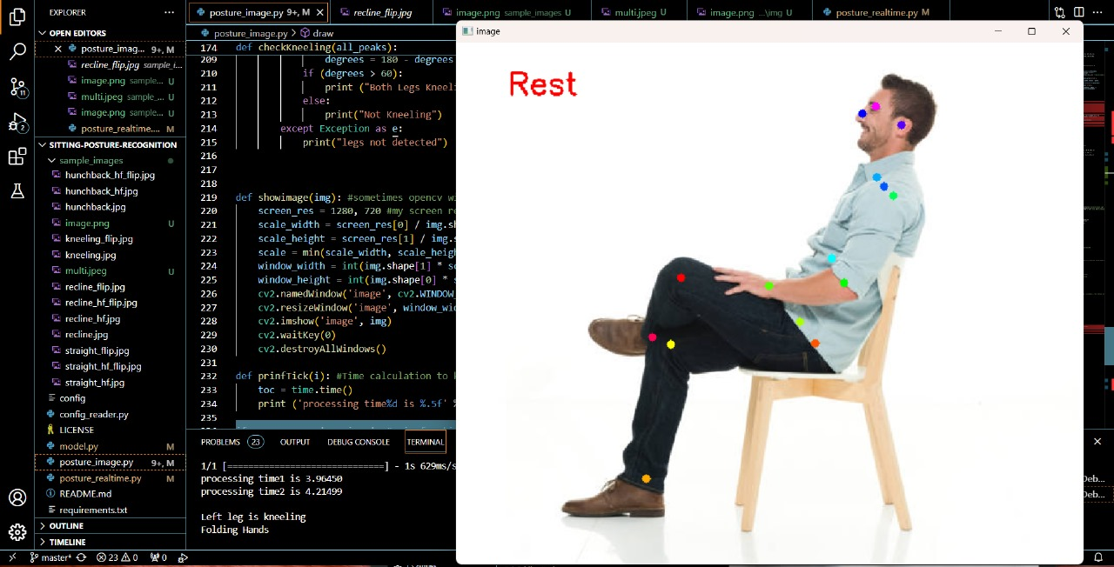
Figure 6.3 Resting posture of a man

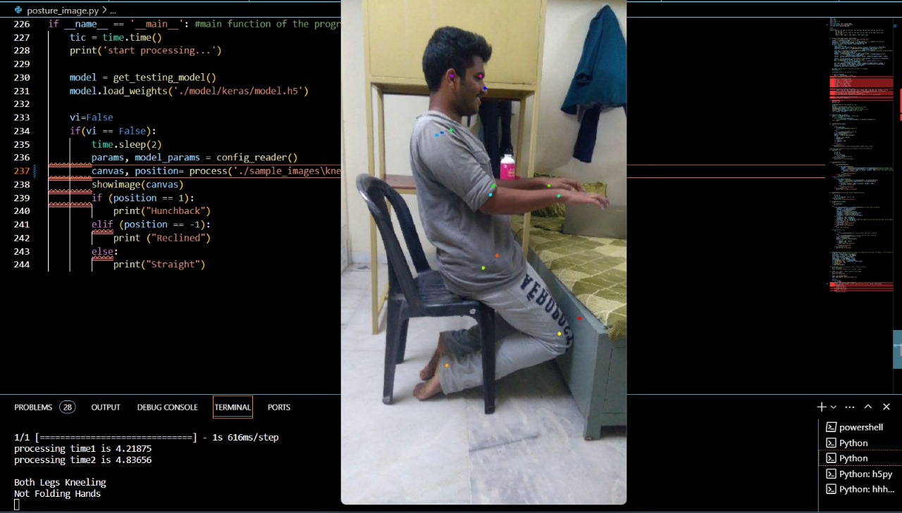
Figure 6.4 Straight sitting posture of a man

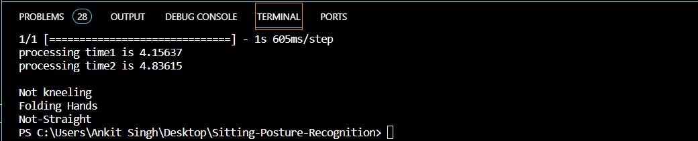
Figure 6.5 Output Image

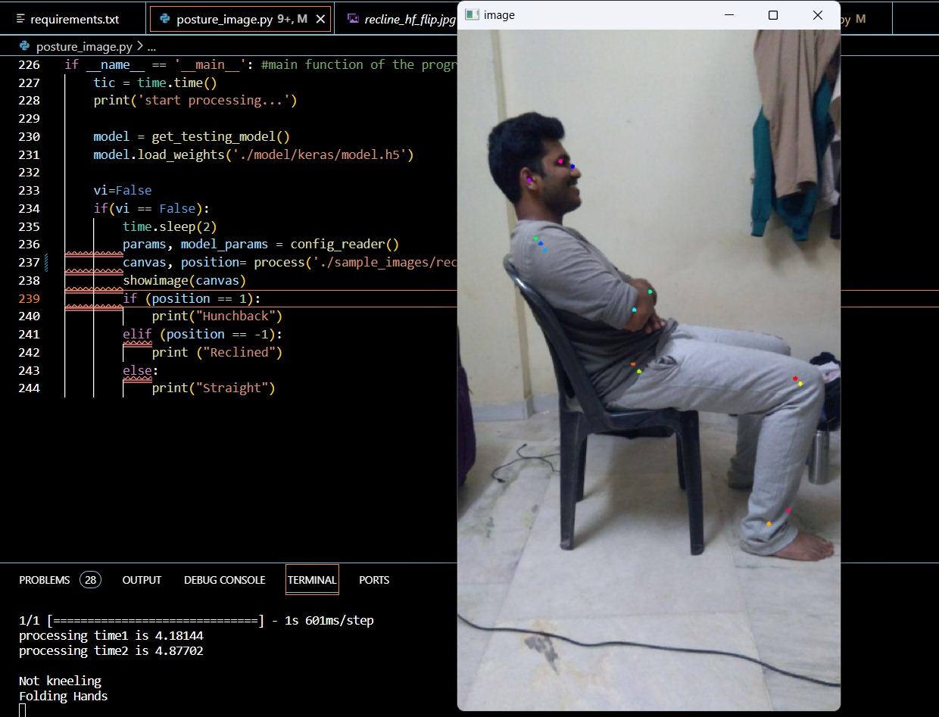
Figure 6.6 Lean sitting posture of a man

6.2 DISCUSSION
Effective implementation of a smart system for workplace posture monitoring encounters several challenges and considerations that need careful attention:

Ergonomic Setup Variability:
The diverse home environments of telecommuters present a notable challenge as setups may vary significantly, impacting the system's ability to adapt to the nuances of different workstations.
Limited Physical Interaction:
The system lacks physical intervention capabilities, limiting its capacity to actively correct or adjust the user's posture. This absence of real-time adjustments may impede immediate improvements in ergonomic practices.

User Compliance and Engagement:
Ensuring consistent user engagement and compliance with the system's recommendations is a persistent challenge. Users may disregard or forget to follow suggested postural adjustments, compromising the overall effectiveness of the system.
Privacy Concerns:
The utilization of real-time video processing raises privacy concerns, involving continuous monitoring of the user's body. The system must be implemented with robust privacy measures to safeguard sensitive information.
System Calibration for Diverse Users:
Calibration of the system to accommodate diverse body types and postural habits poses a challenge. A one-size-fits-all approach may prove ineffective, necessitating a system capable of adapting to the unique characteristics of different users.
Potential for False Positives/Negatives:
Despite an accuracy rate exceeding 80%, the system may still encounter instances of false positives or negatives. Addressing these occurrences is crucial to ensure the reliability of postural detection.
Adaptability to Dynamic Work Environments:
The system may face challenges in adapting to dynamic work environments where telecommuters frequently change their work locations or switch between different devices. Its adaptability to such changes is essential for continuous monitoring.
Network and Connectivity Issues:
The reliance on real-time video processing demands stable network connectivity. Any disruptions or latency issues may affect the system's ability to provide timely feedback, impacting its overall effectiveness.

These challenges collectively underscore the complexity of implementing a smart system for workplace posture monitoring and highlight the need for a meticulous approach to overcome these hurdles for the system's successful integration into diverse telecommuting environments.

CHAPTER 7
CONCLUSION AND FUTURE ENHANCEMENT

7.1 CONCLUSION
The culmination of our project, titled "Human Pose Estimation using OpenCV & Python" marks a significant stride towards enhancing the well-being of the telecommuting workforce. Through a meticulous exploration of ergonomic challenges and the potential health risks associated with extended computer usage, the project has introduced an innovative solution designed to actively detect and analyse the postures of telecommuting employees. By addressing the pressing need for real-time feedback on posture and advocating for comfortable and proper positioning, the system stands as a proactive measure against musculoskeletal issues and other health concerns prevalent in remote work settings.
The integration of cutting-edge technology, particularly Convolutional Neural Networks (CNNs) embedded in specialized hardware, showcases the commitment to efficient real-time video processing. This not only ensures accurate posture detection, encompassing key elements such as the neck, shoulders, and arms but also goes beyond detection by providing personalized recommendations to telecommuters. The gamification aspect, turning posture correction into an engaging challenge, adds an element of motivation for users to actively participate in maintaining healthy postures.

Emphasizing real-time video processing, the project achieves processing speeds of up to 25 frames per second, enabling continuous posture monitoring throughout telecommuters' work activities. Prioritizing sustainability, the system is designed with minimal power consumption (below 10 watts), making it practical for prolonged use without significantly impacting the user's device or increasing energy consumption.

The accuracy rate exceeding 80% in posture detection underscores the reliability and effectiveness of the system, contributing to long-term posture improvement and overall health. Beyond immediate applications, the project envisions the potential for the system to expand into remote health monitoring, capturing posture-related data and providing a holistic view of the telecommuter's health status.
Ensuring seamless integration into diverse telecommuting environments, the project lays the groundwork for a user-friendly implementation. The potential development of a mobile application or desktop dashboard enhances accessibility, allowing users to conveniently access posture data, recommendations, and progress reports.

Looking ahead, the continuous learning algorithms implemented in the system promise adaptability to changing work environments and habits, ensuring its effectiveness in diverse telecommuting scenarios. The comprehensive privacy measures, including encryption and secure data transmission protocols, address concerns related to user data, maintaining confidentiality throughout posture monitoring.

Incorporating remote monitoring capabilities and a module for the long-term impact assessment, the project acknowledges the dynamic nature of telecommuting and positions itself as a forward-thinking solution within the evolving landscape of occupational health. As workplaces evolve and the significance of employee well-being gains prominence, the Smart System for Workplace Posture Monitoring stands as a testament to the commitment to healthier work habits, promoting proactive health management in the realm of telecommuting.

7.2 FUTURE ENHANCEMENT

Multi-Sensor Integration:
Explore the integration of additional sensors, such as depth sensors or inertial measurement units (IMUs), to enhance the system's ability to capture a more comprehensive range of posture-related data. This could provide a more holistic understanding of user positions and movements.

Machine Learning Refinement:
Continuously refine and expand the machine learning models used for posture detection. Implement advanced algorithms or ensemble models to improve accuracy and adaptability to diverse user behaviours and work environments.

Dynamic Workstation Profiles:
Develop a system that automatically adapts to different workstation configurations and user preferences. Implement dynamic profiles that adjust posture recommendations based on the specific ergonomic setup of the telecommuter, ensuring personalized and accurate guidance.

Integration with Smart Furniture:
Collaborate with manufacturers of smart office furniture to create an ecosystem where the system communicates with IoT-enabled chairs, desks, or accessories. This integration can provide real-time adjustments to the user's physical environment for optimal posture support.

Expanded Health Metrics Monitoring:
Extend the system's capabilities beyond posture monitoring to include the tracking of additional health metrics. This could involve integrating sensors or algorithms to monitor stress levels, eye fatigue, or other factors contributing to overall well-being during remote work.

Adaptive Augmented Reality (AR) Feedback:
Implement AR feedback that dynamically adapts based on the user's posture. Augmented reality can provide more immersive and personalized guidance, helping users visualize correct postures and adjustments in real-time.

Collaborative Virtual Spaces:
Develop virtual spaces where telecommuters can collaborate and engage in joint activities to promote healthy postures. This could include virtual fitness classes, posture challenges, or shared mindfulness sessions to foster a sense of community among remote workers.

Gamification for Engagement:
Gamify the posture improvement experience by introducing interactive challenges, achievements, or rewards. This approach aims to increase user engagement and motivation in maintaining healthy postures during work hours.

Smart Notifications and Reminders:
Develop an intelligent notification system that provides timely reminders for posture adjustments and breaks. These notifications can be personalized based on user preferences and work patterns, enhancing adherence to recommended postural habits.

Accessibility Features:
Enhance the system's accessibility by incorporating features that cater to users with varying physical abilities. This may include voice-guided exercises, haptic feedback, or other mechanisms to ensure inclusivity and usability for a diverse user demographic.

Privacy-Centric Innovations:
Explore advanced privacy-centric technologies, such as federated learning or on-device processing, to minimize data transmission and protect user privacy while still achieving effective posture monitoring.

Cross-Platform Compatibility:
Ensure compatibility with a wide range of devices and platforms, including different operating systems, ensuring the system's versatility and ease of integration into diverse technological environments.

User Education and Training Modules:
Develop interactive modules within the system to educate users on ergonomic best practices and provide training exercises for strengthening core muscles and improving posture. This educational component can contribute to long-term posture improvement.

REFERENCES

- Milasi, S.; González-Vázquez, I.; Fernández-Macías, E. Telework in the EU before and after the COVID-19: Where We Were, Where We Head to; Science for Policy Brief; European Commission: Brussels, Belgium, 2020.
- Larrea-Araujo, C.; Ayala-Granja, J.; Vinueza-Cabezas, A.; Acosta-Vargas, P. Ergonomic Risk Factors of Teleworking in Ecuador during the COVID-19 Pandemic: A Cross-Sectional Study. Int. J. Environ. Res. Public Health 2021, 18, 5063.
- Moro, A. Impact of the COVID-19 Confinement Measures on Telework in Italy-A Qualitative Survey; Technical Report; JRC Working Papers Series on Labour; Education and Technology: Econstor, Italy, 2020.
- Nag, P.K. Musculoskeletal disorders: Office menace. In Office Buildings; Springer: Berlin/Heidelberg, Germany, 2019; pp. 105–126.
- Ohlendorf, D.; Sosnov, P.; Keller, J.; Wanke, E.M.; Oremek, G.; Ackermann, H.; Groneberg, D.A. Standard reference values of the upper body posture in healthy middle-aged female adults in Germany. Sci. Rep. 2021, 11, 1–10.
- Openshaw, S.; Taylor, E. Ergonomics and Design a Reference Guide; Allsteel Inc.: Muscatine, IA, USA, 2006.
- Woodson, W.E.; Tillman, B.; Tillman, P. Human Factors Design Handbook: Information and Guidelines for the Design of Systems, Facilities, Equipment, and Products for Human Use; McGraw-Hill: New York, NY, USA, 1992.
- Mallare, J.C.T.; Pineda, D.F.G.; Trinidad, G.M.; Serafica, R.D.; Villanueva, J.B.K.; Cruz, A.R.D.; Vicerra, R.R.P.; Serrano, K.K.D.; Roxas, E.A. Sitting posture assessment using computer vision. In Proceedings of the 2017 IEEE 9th International Conference on Humanoid, Nanotechnology, Information Technology, Communication and Control, Environment and Management (HNICEM), Manila, Philippines, 1–3 December 2017; pp. 1–5.
- Van Niekerk, S.M.; Louw, Q.; Vaughan, C.; Grimmer-Somers, K.; Schreve, K. Photographic measurement of upper-body sitting posture of high school students: A reliability and validity study. BMC Musculoskelet. Disord. 2008, 9, 1–11.
- Khandelwal, I.; Stollenwerk, K.; Krüger, B.; Weber, A. Posture Classification Based on a Spine Shape Monitoring System. In Proceedings of the International Conference on Computational Science and Its Applications, Saint Petersburg, Russia, 1–4 July 2019; pp. 494–509.
- Bibbo, D.; Carli, M.; Conforto, S.; Battisti, F. A sitting posture monitoring instrument to assess different levels of cognitive engagement. Sensors 2019, 19, 455.
- Muppavram, S.; Patel, N.; Nadeem, M. Posture Alert. In Proceedings of the 2018 IEEE Region Ten Symposium (Tensymp), Sydney, NSW, Australia, 4–6 July 2018; pp. 213–218.
- Haller, M.; Richter, C.; Brandl, P.; Gross, S.; Schossleitner, G.; Schrempf, A.; Nii, H.; Sugimoto, M.; Inami, M. Finding the right way for interrupting people improving their sitting posture. In Proceedings of the IFIP Conference on Human-Computer Interaction, Lisbon, Portugal, 5–9 September 2011; pp. 1–17.
- Falla, D.; Jull, G.; Russell, T.; Vicenzino, B.; Hodges, P. Effect of neck exercise on sitting posture in patients with chronic neck pain. Phys. Ther. 2007, 87, 408–417.
- Ma, X.; Niu, Y.; Gu, L.; Wang, Y.; Zhao, Y.; Bailey, J.; Lu, F. Understanding adversarial attacks on deep learning based medical image analysis systems. Pattern Recognit. 2021, 110, 107332.
- Tahura, S.; Samiul, S.H.; Kaiser, M.S.; Mahmud, M. Anomaly Detection in Electroencephalography Signal Using Deep Learning Model. In Proceedings of the International Conference on Trends in Computational and Cognitive Engineering, Dhaka, Bangladesh, 7–18 December 2020; pp. 205–217.
- Li, C.; Zhong, Q.; Xie, D.; Pu, S. Skeleton-based action recognition with convolutional neural networks. In Proceedings of the 2017 IEEE International Conference on Multimedia & Expo Workshops (ICMEW), Kuala Lumpur, Malaysia, 3–6 November 2017; pp. 597–600.
- Nvidia. TRT_Pose Repository. Available online: https://github.com/NVIDIA-AI-IOT/trt_pose.
- Xiao, B.; Wu, H.; Wei, Y. Simple Baselines for Human Pose Estimation and Tracking. In Computer Vision—ECCV 2018; Ferrari, V., Hebert, M., Sminchisescu, C., Weiss, Y., Eds.; Springer: Berlin/Heidelberg, Germany, 2018; pp. 472–487.
- Nvidia. Official Repository of Tool Torch2trt. Available online: https://github.com/NVIDIA-AI-IOT/torch2trt (accessed on 28 May 2021).
- Zhou X, Huang Q, Sun X, Xue X, Wei Y. Towards 3D human pose estimation in the wild: A weakly-supervised approach; Proceedings of the IEEE International Conference on Computer Vision; Venice, Italy. 2017. pp. 398–407.
- Xiao B, Wu H, Wei Y. Simple baselines for human pose estimation and tracking; Proceedings of the European Conference on Computer Vision (ECCV); Munich, Germany. 2018. pp. 466–481.
- Ma N, Wu Z, Cheung YM, Guo Y, Gao Y, et al. A survey of human action recognition and posture prediction. Tsinghua Science and Technology. 2022;27(6):973–1001. doi: 10.26599/TST.2021.9010068.
- Federolf PA. A novel approach to study human posture control: Principal movements obtained from a principal component analysis of kinematic marker data. Journal of Biomechanics. 2016;49(3):364–370. doi: 10.1016/j.jbiomech.2015.12.030.
- Fan Z, Hu X, Chen WM, Zhang DW, Ma X. A deep learning based 2-dimensional hip pressure signals analysis method for sitting posture recognition. Biomedical Signal Processing and Control. 2022;73(2):103432. doi: 10.1016/j.bspc.2021.103432.
- Islam MM, Nooruddin S, Karray F. Multimodal human activity recognition for smart healthcare applications; 2022 IEEE International Conference on Systems, Man, and Cybernetics (SMC); Prague, Czech Republic. 2022. pp. 196–203.
- Siddiqui M. Human pose estimation from a single view point; Computer Vision and Pattern Recognition Workshops (CVPRW), 2010 IEEE Computer Society Conference; San Francisco, CA, USA. 2010. pp. 1–8.
- Liu G, Lin L, Zhou W, Zhang R, Guo H. A posture recognition method applied to smart product service. Procedia CIRP. 2019;83(12):425–428. doi: 10.1016/j.procir.2019.04.145.
- Hernández-Vela A, Bautista MÁ, Perez-Sala X, Ponce-López V, Escalera S, et al. Probability-based dynamic time warping and bag-of-visual-and-depth-words for human gesture recognition in RGB-D. Pattern Recognition Letters. 2014;50(2):112–121. doi: 10.1016/j.patrec.2013.09.009.
- Onishi K, Takiguchi T, Ariki Y. 3D human posture estimation using the HOG features from monocular image; 2008 19th International Conference on Pattern Recognition; Tampa, FL, USA. 2008. pp. 1–4.

PUBLICATION PROOF

Hello,

The following submission has been created.

Track Name: MAiTRI2024

Paper ID: 266

Paper Title: Smart System for Workplace Posture Monitoring using deep learning-based convolutional neural networks (CNNs).

Abstract:
The shift from traditional in-person work to telecommuting, prompted by the pandemic, has led to a significant increase in the amount of time employees spend in front of computers. This prolonged screen time, often coupled with makeshift home workstations, has raised concerns about ergonomic standards and the potential health implications of prolonged incorrect posture. Recognizing the importance of addressing these occupational health risks, particularly in the context of remote work, there is a pressing need for innovative solutions capable of quantifying and mitigating the prevalence of incorrect postures among telecommuting employees. In response to this imperative, the present study introduces a sophisticated automated system designed to detect and analyze the posture of teleworkers. This system leverages state-of-the-art technology, including specialized hardware and advanced convolutional neural networks, to process real-time video feeds of telecommuters in their home environments. The system's primary objective is to identify and evaluate key postural indicators, including the positioning of the neck, shoulders, and arms. By meticulously analyzing these crucial elements, the system can provide valuable insights and recommendations aimed at preventing potential health issues associated with poor posture.

Created on: Mon, 15 Apr 2024 16:38:00 GMT

Last Modified: Mon, 15 Apr 2024 16:38:00 GMT

Authors:
- as0180@srmist.edu.in (Primary)
- as2345@srmist.edu.in
- karthikm1@srmist.edu.in

Primary Subject Area: Computer Vision

Secondary Subject Areas: Deep Learning

Submission Files: MajorProject_BasePaper_Edited[1][1][1][1].pdf (443 Kb, Mon, 15 Apr 2024 16:34:48 GMT)

Submission Questions Response:
1. Title of the Paper
Smart System for Workplace Posture Monitoring using deep learning-based convolutional neural networks (CNNs).
Thanks,CMT team.



PLAGARISM REPORT


FORMAT-I

S R M I N S T I T U T E O F S C I E N C E A N D T E C H N O L O G Y
(Deemed to be University u/ s 3 of UGC Act, 1956)
Office of Controller of Examinations
REPORT FOR PLAGIARISM CHECK ON THE DISSERTATION/PROJECT REPORTS FOR UG/PG PROGRAMMES
(To be attached in the dissertation/ project report)
1 | Name of the Candidate (IN BLOCK LETTERS) | ANKIT SINGH  ARNAV SRIVASTAVA
2 | Address of the Candidate | F401- Abode valley Potheri  F401- Abode valley Potheri
3 | Registration Number | RA2011003010410  RA2011003010415
4 | Date of Birth | 02/12/2002  15/08/2002
5 | Department | Computer Science and Engineering
6 | Faculty | Engineering and Technology, School of Computing
7 | Title of the Dissertation/Project | Smart System for Workplace Posture Monitoring using deep learning-based convolutional neural networks (CNNs)
8 | Whether the above project /dissertation is done by | Individual or group : (Strike whichever is not applicable)  - If the project/ dissertation is done in group, then how many students together completed the project :  - Mention the Name & Register number of other candidates :
9 | Name and address of the Supervisor / Guide | Dr. M. KARTHIKEYAN  Mail ID: karthikm1@srmist.edu.in  Mobile Number: 9994185313
10 | Name and address of Co-Supervisor / Co- Guide (if any) | Mail ID:  Mobile Number:
11 | Software Used | Turnitin
12 | Date of Verification | 26/04/2024
13 | Plagiarism Details: (to attach the final report from the software)
Chapter | Title of the Chapter | Percentage of similarity index (including self  citation) | Percentage of similarity index (Excluding  self-citation) | % of plagiarism after excluding Quotes, Bibliography, etc.,
1
2
3
4
5
6
7
8
9
10
Appendices
I / We declare that the above information have been verified and found true to the best of my / our knowledge.
Signature of the Candidate |  | Name & Signature of the Staff (Who uses the plagiarism check software)
Name & Signature of the Supervisor/ Guide |  | Name & Signature of the Co-Supervisor/Co-  Guide
Name & Signature of the HOD

